



**The kingdom of Saudi Arabia**

**Al-imam Mohammed bin Saud**

**2021**

**Computer Science**

**Software engineering**

**Level 4**



**The unified technical system for government agencies**



**Team members:**

**Hanan Almutairi**

**Hnan Almutairi**

**440022269**

**Rawan Aljibreen**

**440019736**

**Instructor:**

## 

## 

From the date of 14-02-2021 To date 25-04-2021

From the date of 14-02-2021 To date 25-04-2021

Table of Contents

**project descrpion 1**

**Main goals and objectives of the project 3**

**Main functionality and characteristics 3**

**Intended users and key usability goals 3**

**The Challenges that encountered us during the project’s development 4**

**Intended technology 4**

**Team members roles and Skills 5**

**Project expected timeline 6**

Software Development Lifecycle: 7

**Why we choose this sldc 7**

**Work breakdown: 8**

Software Requirements Specification 9

1. Introduction 9

**1.1 Purpose 9**

**1.2 Scope 9**

**1.3 Reference 9**

2. Overall Description 10

**2.1 Product Perspective: 10**

**2.2 Product Features: 10**

**2.3 User Characteristics: 12**

**2.4 Design and Implementation Constraints: 12**

**2.5 Assumptions and Dependencies: 13**

3. functional requirements 14

**3.1 Taxonomies management: 14**

**3.2. Government agencies management 16**

**3.3.Government agencies and branches classification 20**

**3.4 Committees management: 22**

**3.5. Search services 24**

**3.6 Forms and procedures management : 28**

**3.7 Users and privileges 29**

**3.8 Analytics and reports 32**

**3.9 Technical support 34**

**3.10 Applicati on Programming Interface management 36**

**3.11 services search Public 37**

**3.12 Public reports services 38**

4. Other Nonfunction Requirements 39

**4.1 Product requirement: 39**

**4.1 Organizational requirement: 41**

5. Other requirements 46

**6._System Models:………………………………………………………………………………47**

**7._Sprint:………………………………………………………………………………………53**

**8._ System Interface:…………………………………………………………………………56**

**9._ Link to The Prototype:…………………….……………………………………………..62**

**10._Architectural design and pattern:………………………………………………………63**

**10.1._Why we choose:…………………………………………………………………………………..64**

**11._The Implementation:……………………………………………………………………..65**

12. Appendix: 66

**Project Description**

**Main goals and objectives of the project**

The National Center for Documentation and Archives is working on a project to build and develop a technical system for the unified classification of Governmental agencies and the system should provide the possibility of building new future classifications and put government agencies in These classifications and link the unified classification to other existing classifications.

**Main functionality and characteristics**

1. Facilitating the process of classifying government agencies in functional sectors / functional groups / functional categories
2. - The possibility of adapting the proposed system to the current systems in place in the center or in the government agencies that It has classifications.
3. The possibility of identifying branches of government agencies with the Original agencies, or with the functional sectors / or with the functional groups / or with the functional categories or with regions or with provinces or with geographical centers.
4. The possibility of hosting the data of the bodies concerned with classification (Ministry of Finance, Ministry of Civil Services General Authority for Statistics).
5. The possibility of work governance in classifying government agencies.
6. The possibility of working on the classification by government agencies to include their branches.
7. Facilitate access to the updated information for the classification of government agencies (according to several determinants such as their type, location, size, and number of employees) as well as regions, governorates and centers according to their subordination, and the branches of government agencies and their location according to the sector, entity, region, governorate or center in which they are located so that they are Available on the electronic portal and easy to use.

**Intended users and key usability goals**

* Government agencies employees: Facilitate communication and exchange of information between government agencies, and they can also benefit from the system in facilitating decision-making regarding overlapping tasks between government agencies in the same sector.
* System Administrator: The system administrator has full authority to control all the tasks and functions of the system, for example (deleting, adding or modifying the classifications, determining access authorities for the system) and other tasks that will be discussed later in detail in the SRS file.
* Committee members: Members of the National Center for Documentation and Archives Committee and the beneficiaries of the committees' management services, for example, but not limited to, notification of session dates, and the ability to access committee minutes added by the system administrator and their ability to amend, accept or reject it , and other services detailed in

the SRS file.

* Individuals (the public): allow them search in all classifications, including unified and geographical classification, classification of government agencies and their branches, and they can also extract, display and print all types of reports available in the system

**The Challenges that encountered us during the project’s development**

* Understanding the project took time
* Difficulty choosing a model between spiral, waterfall, incremental and iterative......

**Intended technology**

* By using these formats (XML, JSON and CSV) we develop three programmatic readable classification formats.
* With these formats (XML, JSON, CSV) we will import one or more classifications.
* With these formats (XML, JSON, CSV, PDF, WORD) we will export one or more classifications.
* For the system administrator we will provide an integrated dashboard.
* Providing an excel file which enables government agencies to enter the data of their branches in fields identical to the fields used in the system.
* Connecting the system to the GSN network and ensuring its work with the provision of the necessary devices for that when needed.
* Connect GSN network with the system to ensure its work, and provide the necessary devices when it's needed.
* Export reports to different formats such as, html, excel, pdf, word.
* Enable the system administrator to create new templates for displaying reports or modifying existing templates based on WYSIWYG mode.
* The ability to export the form and all information related to it in PDF format.
* Provides a Wizard-based query builder for the System Administrator without the need to write code.
* The system must be able to compare two tables to each other in terms of data or content structure, as government agencies take a hierarchical form (tree data structure) if there are several tables for government agencies.
* For royal orders and regulations we will able to attach a copy (tiff, pdf).
* Export a classification to an interactive HTML5 webpage.
* By using languages including JAVA and JavaScript we will explaining examples of APIs.
* we will use a three-tier servers' architecture: ( Web server, Application server, Database server ).
* The report building wizard should include a builder query wizard with a graphical explanation of the SQL instructions used.
* Support showing reports in different display ways such as tables, infographics, geographical maps, graphs, dashboards.
* The reporting wizard and the reports that will be generated by the contractor should support the following properties: Filters, sorting, grouping, blending.
* The system must provide points of contact for all system services and functions.
* The system should be designed based on responsive web design.
* Total reliance on CSS to control the appearance of all system content.
* Use pagination techniques to display long, detailed contents with a conveniently designed progress bar.
* Follow the principles of object-oriented programming.

**Team members roles and Skills**

**Team Members**

.

|  |  |  |  |  |
| --- | --- | --- | --- | --- |
| Hanan | Rawan | Razan | Ghadeer | Skills |
|  | Checkmark with solid fill |  |  | Team leader |
| Checkmark with solid fill |  | Checkmark with solid fill |  | Coding |
|  | Checkmark with solid fill |  | Checkmark with solid fill | Designing |
|  |  | Checkmark with solid fill |  | Corrector |
| Checkmark with solid fill | Checkmark with solid fill | Checkmark with solid fill | Checkmark with solid fill | Researcher |
| Checkmark with solid fill | Checkmark with solid fill | Checkmark with solid fill | Checkmark with solid fill | Communication |
| Checkmark with solid fill | Checkmark with solid fill | Checkmark with solid fill | Checkmark with solid fill | Hard worker |
| Checkmark with solid fill | Checkmark with solid fill | Checkmark with solid fill | Checkmark with solid fill | Passion/creativity |

|  |  |  |  |  |  |  |
| --- | --- | --- | --- | --- | --- | --- |
| Team roles | | | | | Tasks | phases |
| **Hanan** | **Rawan** | **Razan** | **Ghadeer** |  |
| Harvey Balls 50% with solid fill | Harvey Balls 50% with solid fill | Harvey Balls 50% with solid fill | Harvey Balls 50% with solid fill | Specification | 1 |
| Harvey Balls 50% with solid fill | Harvey Balls 50% with solid fill | Harvey Balls 50% with solid fill | Harvey Balls 50% with solid fill | Analysis |
| Harvey Balls 10% with solid fill | Harvey Balls 90% with solid fill | Harvey Balls 10% with solid fill | Harvey Balls 90% with solid fill | Design | 2 |
| Harvey Balls 90% with solid fill | Harvey Balls 10% with solid fill | Harvey Balls 90% with solid fill | Harvey Balls 10% with solid fill | Coding |
| Harvey Balls 50% with solid fill | Harvey Balls 50% with solid fill | Harvey Balls 50% with solid fill | Harvey Balls 50% with solid fill | Testing | 3 |

**Project expected timeline**

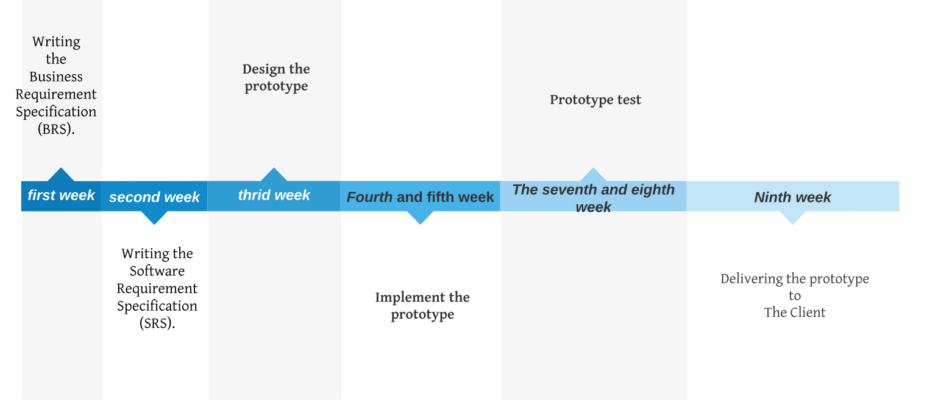

**Software Development Lifecycle:**

**Why we choose this sldc**

* We chose the iterative model because the choice between the waterfall model and the spiral model Baffled us, because The client's requirements were clear to us, but there are some requirements that will be added in the future by the client, and as is clear from the system, it needs a high degree of safety and future risk management ,So we decided to use the iterative model because it combines the two in good proportions.

And also one of the features of the model that help us in the project:

* That Most of the requirements are known in advance but are expected to evolve over time.
* Priority has been given to some requirements.
* That The domain is new to the team.

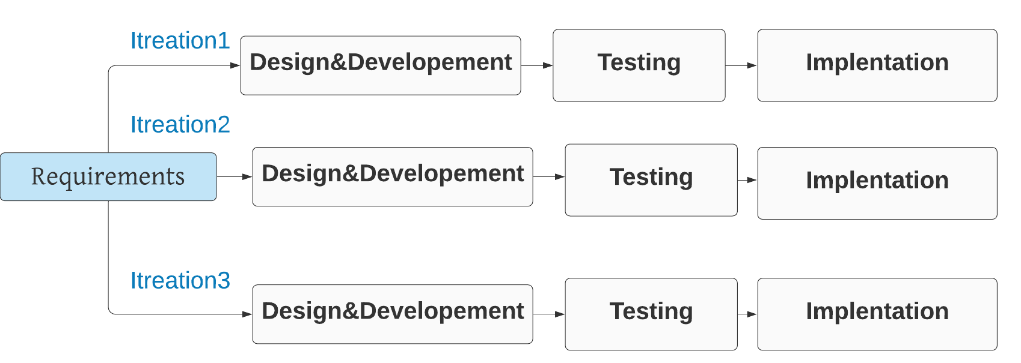

**Work breakdown:**

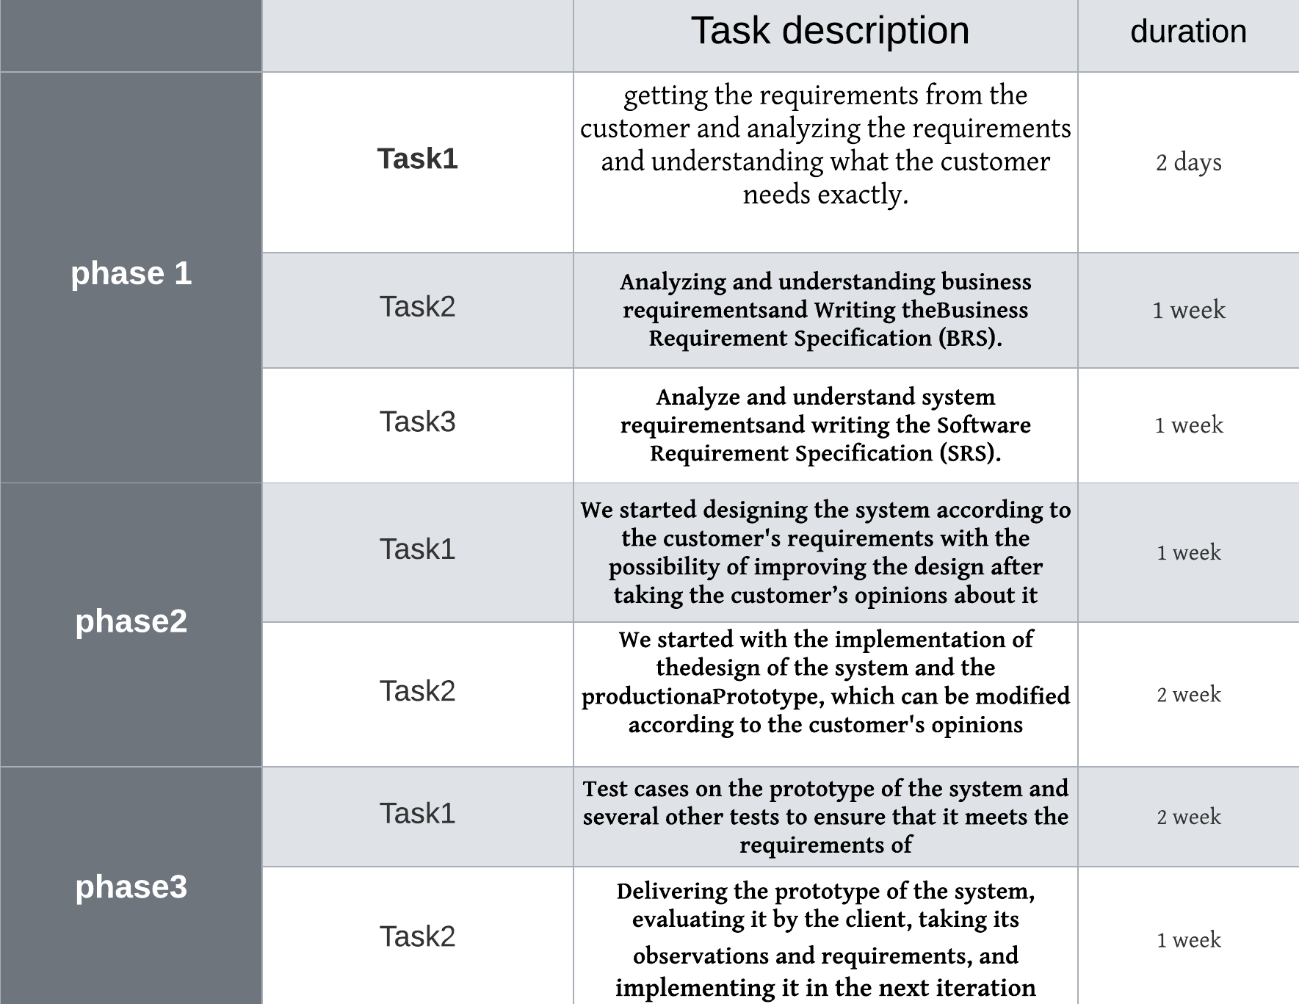

**Software Requirements Specification**

# Introduction

The following section provides an overview of the software requirement specification (SRS) for the Technical system for unified classification of government agencies

## Purpose

Building and developing the technical system for the unified classification of government agencies to achieve the requirements of the Council of Ministers' decision

## Scope

With the cooperation of the United Nations Organization UN with the Economic Cooperation Organization OECD and the adoption of the Financial Statistics 2014 classification as a guide on which to build the unified classification of government agencies and the housing of government agencies in sectors and provide a system that can build new future classifications and accommodate government agencies in these classifications and link the unified classification with other existing classifications.

## Reference

Because we haven't used any existing system as a start for us or as a reference, actually we haven't used any reference yet. However we Took the template from IEEE software engineering standard by Karle E.Wiegers version 2002

# Overall Description

**2.1 Product Perspective:**

The system consists of 3 parts, a mobile application, a web application, and a Stand-alone hardware device that contains a complete copy of the system.

Committee members benefit from the mobile application so that they have all the committee services through it, including notifications of session dates and other services detailed in the functional requirements section and for its need for some data in the implementation of these services, it needs to connect to the database through the web server as shown in figure1

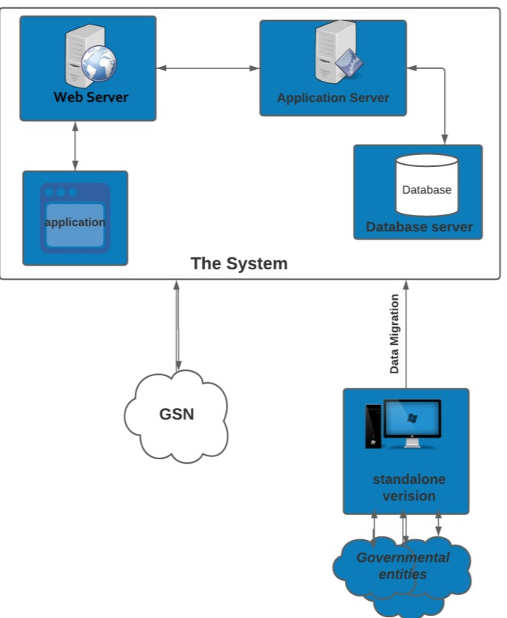

**F**

**igure**

**1**

**-**

**B**

**lock**

**diagram**

Web applications are used by members of the committee or employees of government agencies or the general public so that the system is accessed through it by connect to the web server, which in turn will connect to the center's database to fetch the necessary data to benefit from the services of the unified classification system according to the validity of each of them.

The stand-alone system is a device that contains a complete copy of the system aimed at collecting the necessary data to achieve the objectives of the unified classification of government agencies from government agencies without linking with the servers, and transferring data from this

stand-alone system to the main system

In order to keep all the data necessary for system services, it is saved in a database that is accessed by the application

server and to which the web server is connected and connected to the web applications and the mobile application figure1

**2.2 Product Features:**

Summarize the major features the product contains or the significant functions that it performs or lets the user perform. Details will be provided in Section 3:

* Taxonomies management: the possibility of building a new classifications and sub-levels added to it and the ability to amend it by deleting, adding, or changing according to the user's authority of the system.
* Government agencies management: the possibility of adding a new government agency and linking all government agencies with all the orders and regulations related to it, and the ability to amend it by deletion or change the name, and the possibility of merging or separating two government agencies according to the user’s authority of the system.
* Government agencies and branches classification: the ability to of linking a government agency or branch with one or more elements of classification, amending it or canceling it, and linking a government agency or branch with more than one classification.
* Committee management: the ability to create an unlimited number of committees and sessions, and amend it by deletion or addition, and the ability to share meeting minutes with committee members and approve it electronically through the electronic signature feature.
* Search services: the ability to search in government agencies and it branches and search in committee records, tables and system fields using an easy-to-use query building wizard without the need to write software codes (Wizard-based query builder) with determining the validity of data access for each query.
* Forms and procedures management: the ability of the system administrator to add new forms with specifying the sequence of filling out the parts of the form and the ability to link each part as a task for a user to complete it with the ability to specify a time limit for each part by the system administrator.
* Defining Users and privileges: the ability to provide an integrated interface for the system administrator with all tasks according to his authority and the ability to add new users to the system and providing their own registration page and another for government agencies with the ability to delete, disable or activate users.
* Provide Analysis and Reports: The ability to compare government agencies, regions, or specific classification elements, and display the results of comparison in multiple ways, and the ability to create periodic reports and upon request, using a special report-building wizard for the system administrator (Wizard-based report builder) and has the powers to hide or show certain fields and data in the reports according to the user.
* Search services and reports available to public: Providing two independent copies of the system that allows the user to search in all classifications and extract all types of reports available in the main system according to the user's authority, and the system administrator's ability to extract the two copies and update them on the web server.
* Technical support: Providing technical support based on the principle of support tickets and providing an interface for analysis and reports (dashboard) detailed for the technical support case for the system administrator with the ability for the user to open a support ticket.
* Application Programming Interface management: Providing an interface for the system administrator to manage all the APIs with the availability of contact points (endpoints) for all the services and functions of the system and determining their validity by the system administrator and providing statistics Dashboard interface to use the software interface.

**2.3 User Characteristics:**

* Government agencies employees: They are the people who work in government agencies and have access to the system and the beneficiaries of the web application in Facilitate communication and exchange of information between government agencies, and they can also benefit from the system in facilitating decision-making regarding overlapping tasks between government agencies in the same sector, and other services detailed in Section 3.
* System Administrator: The system administrator is the person who have full authority to control all the tasks and functions of the system and they may be several administrators ,for each government agency has it own administrator who his authority to control the system, and they take advantage of the web application, for example but not limited (deleting, adding or modifying the classifications, determining access authorities for the system) and other tasks that will be discussed later in detail in Section 3.
* Committee members: Members of the National Center for Documentation and Archives Committee, beneficiaries of the web and mobile application that contain all committee management services, for example, but not limited to, notification of session dates, access to session minutes added by the system administrator and their ability to amend or accept it Or reject it and the other services detailed in Section3.
* Individuals (the public): They are the users of the two separate versions of the system, one of which contains a search service in all classifications, including unified and geographical classification, classification of government agencies and their branches and the other is for extract, display and print all types of reports available for them in the system

**2.4 Design and Implementation Constraints:**

The system must be designed by relying on the responsive design (responsive web design) and being careful to reduce the number of clicks that the user may need to complete his work as much as possible( Three clicks rule if possible) with total reliance on the CSS language to control the appearance of all the contents of the system and use colors that are compatible with the identity of the National Center for Records and Archives, and must follow the principles of object-oriented programming and All code should be modular, with the delivery of a detailed document explaining examples of use of programming interfaces using more than one language, including Java and JavaScript, and when using external software libraries, these libraries must be with the latest versions and supported for a period of not less than 3 years.

Full support for Arabic fonts must be provided in the system interfaces and database, in addition to full support for the Hijri and Gregorian calendar and activation of the government access feature (Saudi Portal)

And When searching in the system, the search results should appear within a period of no more than 3 seconds and 5 seconds for the results of reports and statistics, regardless of the user's internet speed.

with the importance of the system being at a high level of security and availability, conducting the necessary cyber assessments and resolving all observations discovered during these evaluations before launching the system, the system must keep records in fixed formats for all events that occur to it, for example (login - password error - Add - amend - delete - read - search - extract a report - hold a committee session - vote ... etc.)

**2.5 Assumptions and Dependencies:**

* For system users, it is expected from the general public to connect to the Internet to take advantage of the system services provided to them, and due to the design and implementation restrictions on the system, it is not necessary for them to have high internet quality to use the system.
* for system administrators, government agency employees, or committee members, they are expected to attend workshops guiding the use of the system to be able to use them effectively.
* for the system, it is expected to run on the Windows system. As for the web application, devices must be provided that are compatible with the operating system and the latest version.
* for the phone application, it is expected to run on all operating systems (Android and iOS).

# functional requirements

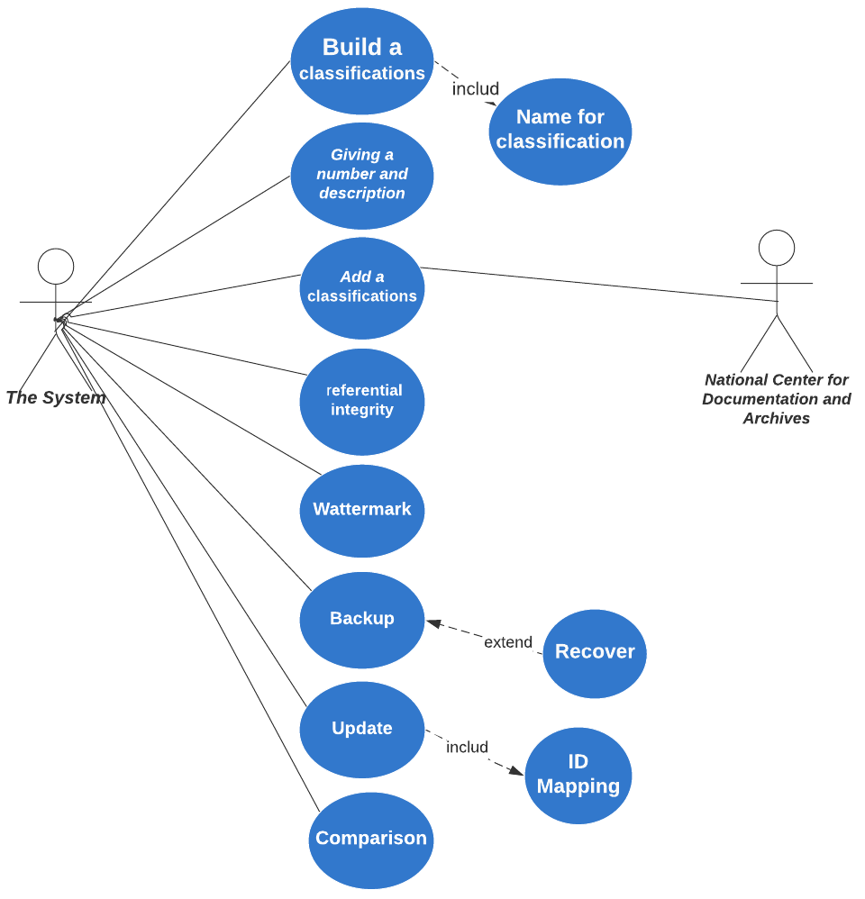3.1 **Taxonomies management:**



Figure 1 use case digram-Taxonomies management

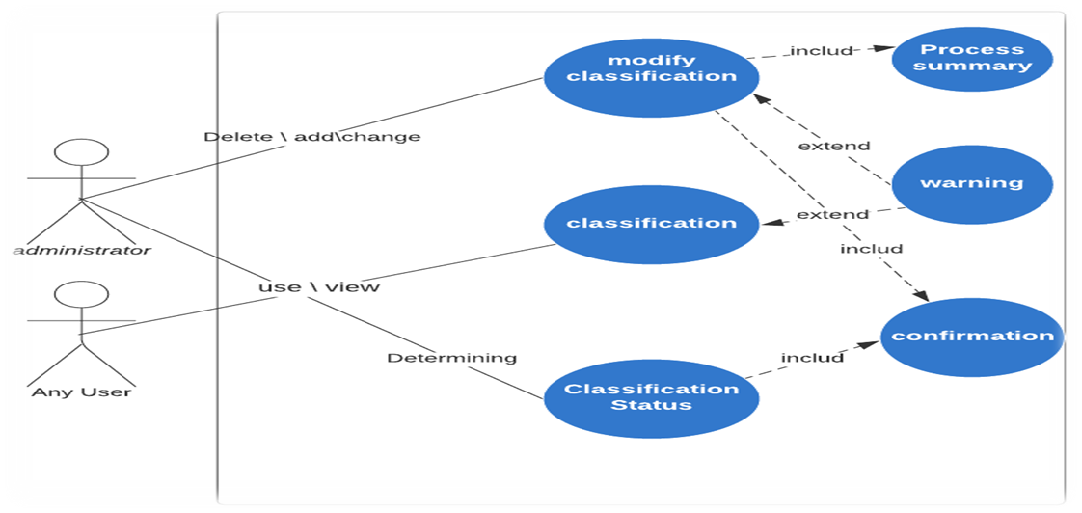

3.1.1Give each level of the rating a name. Example in Geographical classification:

The first level: area.

The second level: a city or province.

Third level: Center.  
  
3.1.2. Development of three programmatic readable classification formulas using the following formulas (XML, JSON , CSV).

3.1.3.Importing a classification or several classifications with the following formulas (XML, JSON , CSV).  
  
3.1.4. Importing a classification or several classifications with the following formulas (XML, JSON , CSV).  
  
3.1.5 Export classification to web page in interactive in HTML5 format.

**3.2. Government agencies management**

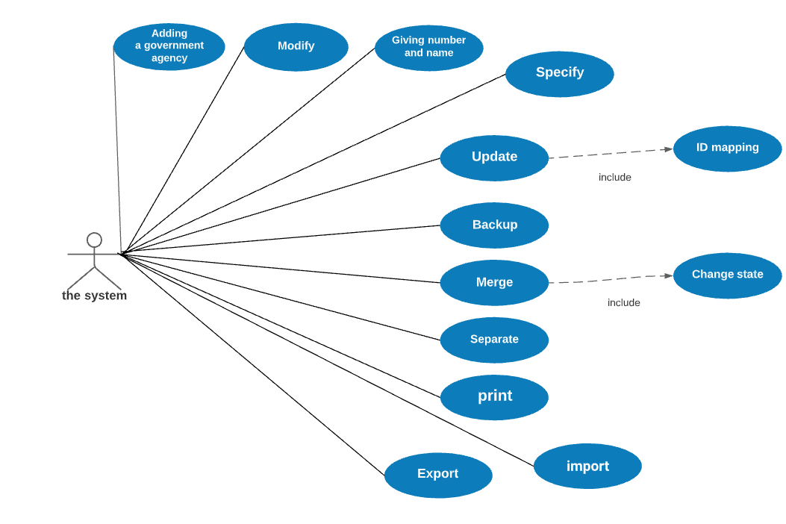



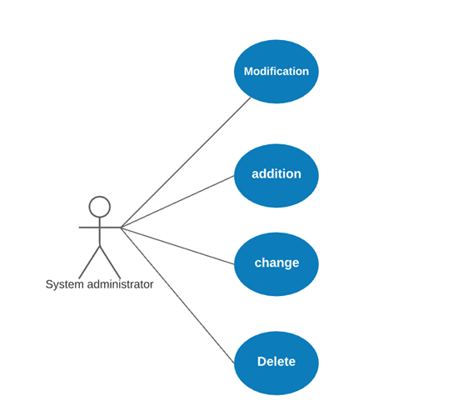

The system shall be able to

3.2.1 Link each government agency with all royal orders and regulations related to it.  
  
3.2.2 Arrange orders and regulations related to a specific government agency according to its type, history, or other sorting and ranking factors.  
  
3.2.3 The possibility of attaching a copy (tiff, pdf), royal orders and regulations.  
  
3.2.4 Saving information related to royal orders (number - date - subject - text content).  
  
3.2.5  Enable each government agency to add its own coding to other government agencies or their branches, provided that it is linked to the unified classification. (Each government agency can have its own device coding the other government and its branches or branches of the device itself, in this case the system must show the symbol used, the system must show the symbol used inside the device as well as the symbol used in the unified classification system).  
  
3.2.6 When changing the status of a government entity, the royal order must be added - The decision related to that while preserving the entity's coding.

3.2.7 Each government agency can add the logo of the government agency logo according to unified standard measurements and specifications.  
  
3.2.8 Keeping a record showing changes and dates related to the cases of each government agency.  
  
3.2.9 Create an account for each government agency.   
  
3.2.10 Create one or more accounts for the system manager for each government agency, while preserving the personal and job information for each government agency system manager.

3.2.11 Link the account of the government apparatus system administrator is linked to the account the official government apparatus.  
  
3.212 Keeping a record of all system administrators in government agencies, the operations they carried out, and everything related to their behavior in using the system.  
  
3.2.13 Accounts of government agencies and system administrators are activated or deactivated through the system administrator at the National Center for Documentation and Archives, with the ability to add notes for each activation or deactivation process.

**3.3.Government agencies and branches classification**

3.2.14 Exporting the data of all government agencies and their branches in the following format (XML, JSON , CSV).  
  
3.2.15 Importing data from government agencies and their branches in formats such as (XML, JSON , CSV).  
  
3.2.16 When there are multiple schedules for government agencies, the system shall be able compare two tables to each other from a structural point of view data or content as government agencies are hierarchical (Tree data structure).  
  
3.2.17 Adding all government agencies and filling in all their data and the branches of each agency according to the data provided by the National Center for Documentation and Archives and according to the center's rules and mechanism for entering data.  
  
3.2.18 Determine the geographical location of the government agency center or branches and show it on the map in in system.  
  
3.2.19 Export the structure of a government agency or branch to a format XML, JSON , CSV.

3.2.20 Importing the structure of a government agency or branch from a format XML, JSON , CSV.  
   
3.2.21 The government agency shall be able to send notes through the system to the National Center for Documentation and Archives.  
  
3.2.22 The government agency shall be able to send notes through the system to the National Center for Documentation and Archives.

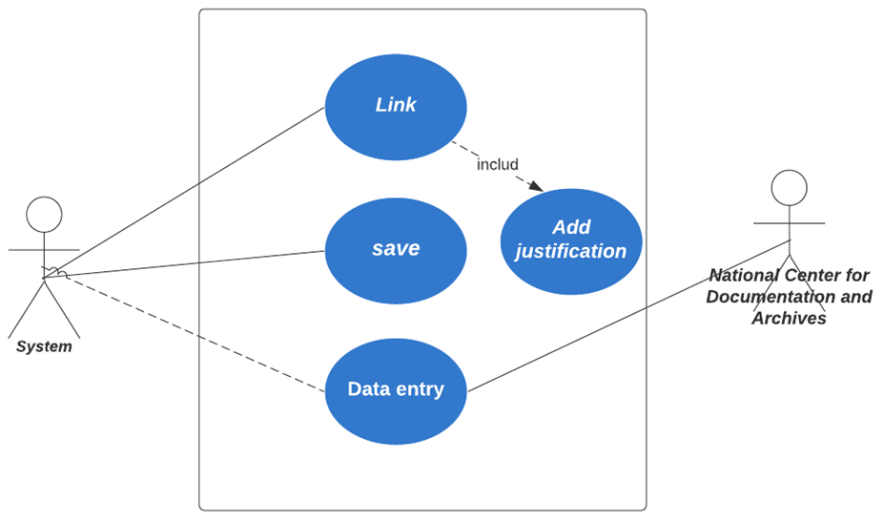

3.3.1. The system shall be able to select a classification from the list of available classifications in the system (such as Unified classification or geographical classification) and showing all its components.

3.3.2. The system shall be able to Support the implementation of the linking (Soothing process using a clear and easy-to-use template(From based).

3.3.3. The system shall be able to Attach all decisions related to device housing operations governmental or branch in PDF format.

3.3.4. The system shall be able to Exporting a government agency’s housing case to a PDF file with the ability to specify the information the case includes (such as: the classifications in which the government agency is housed and the names of the associated elements, justifications for the housing).

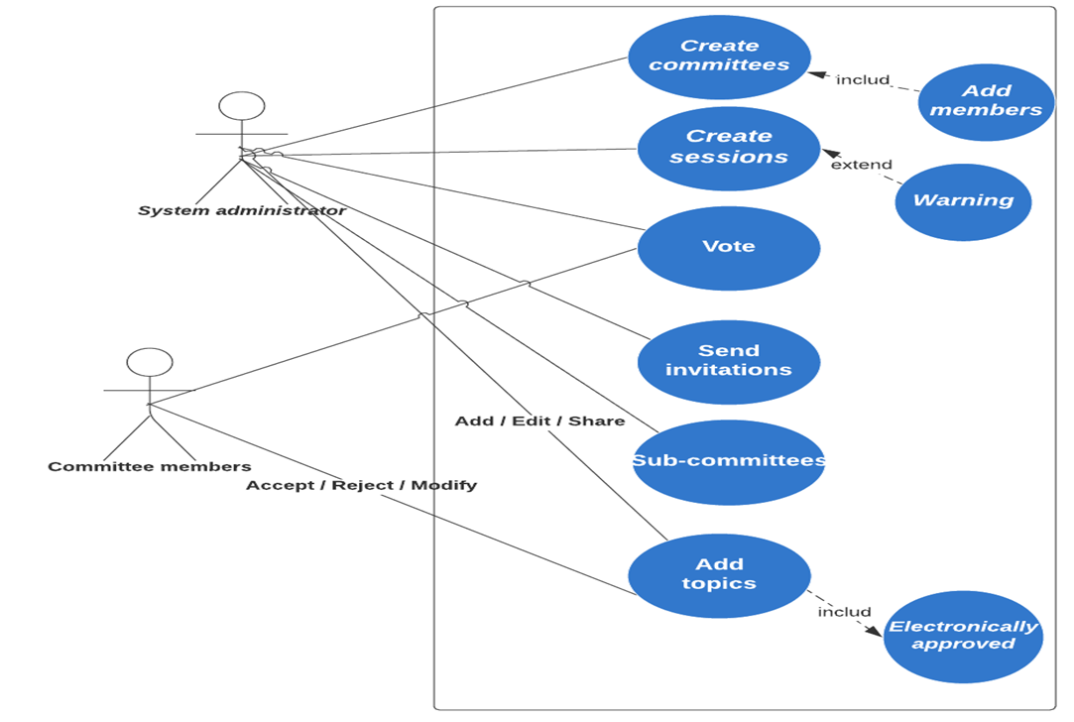**3.4 Committees management:**

Figure 2-Committees management

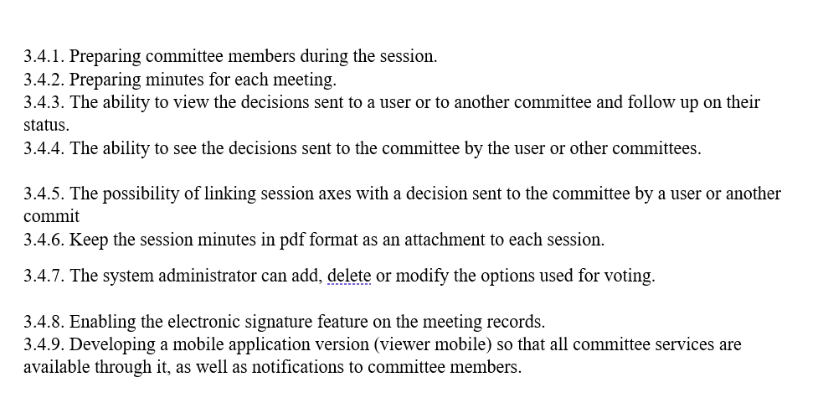

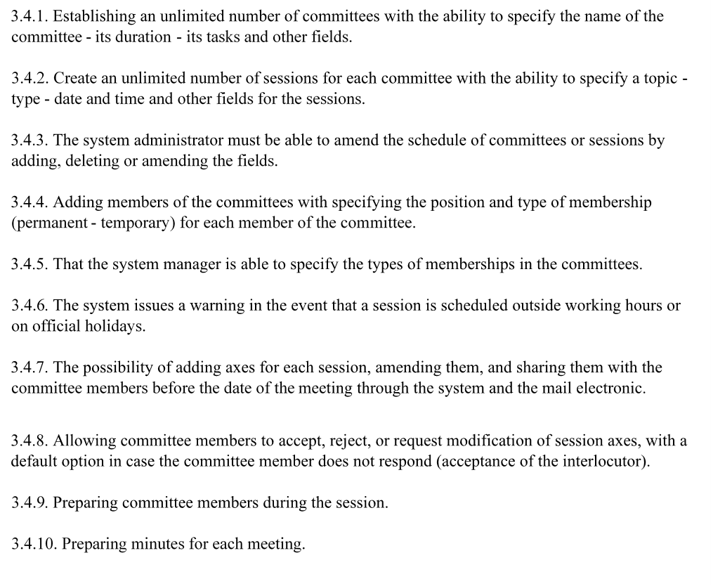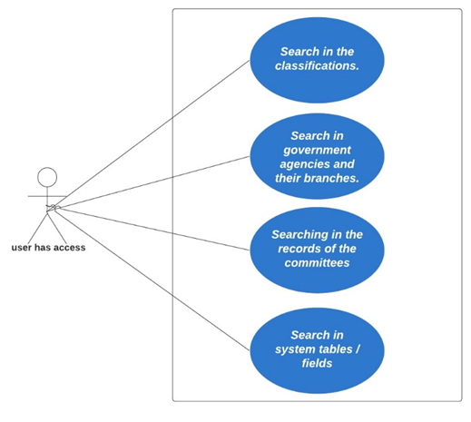**3.5. Search services**

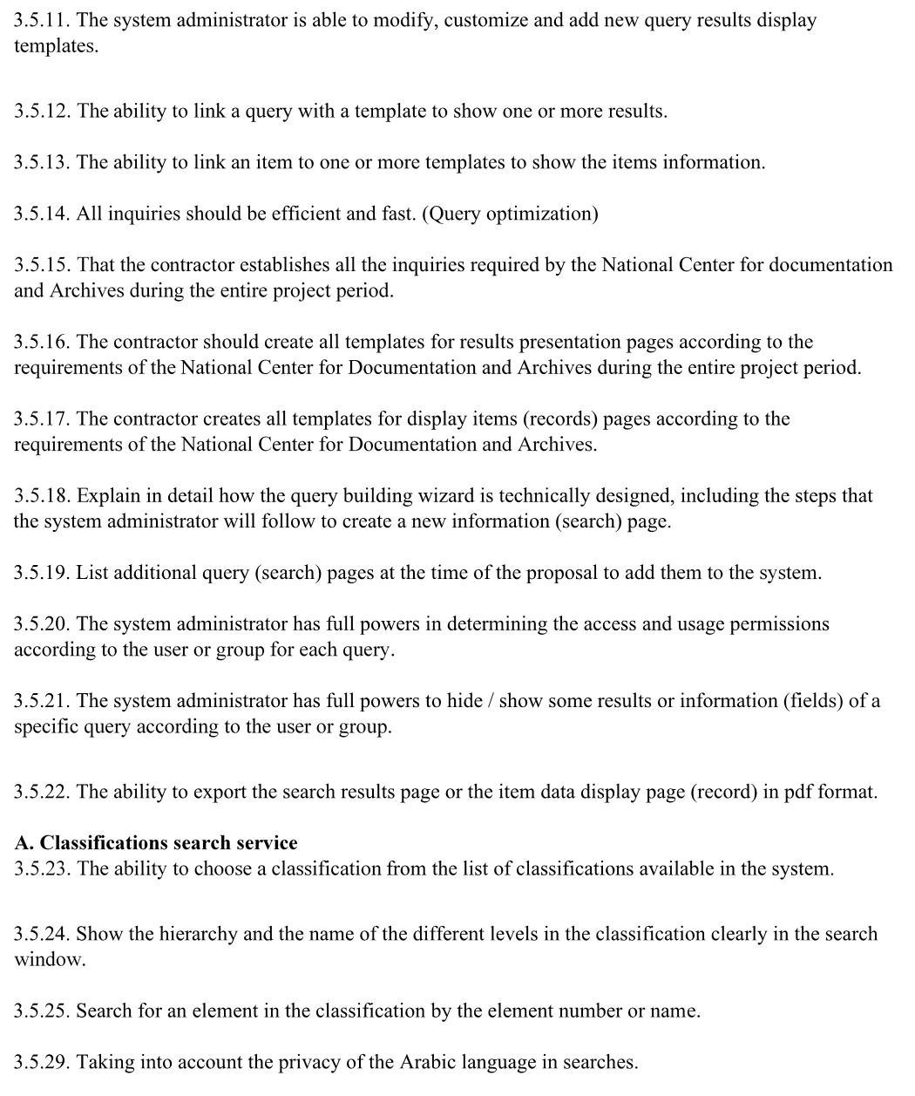

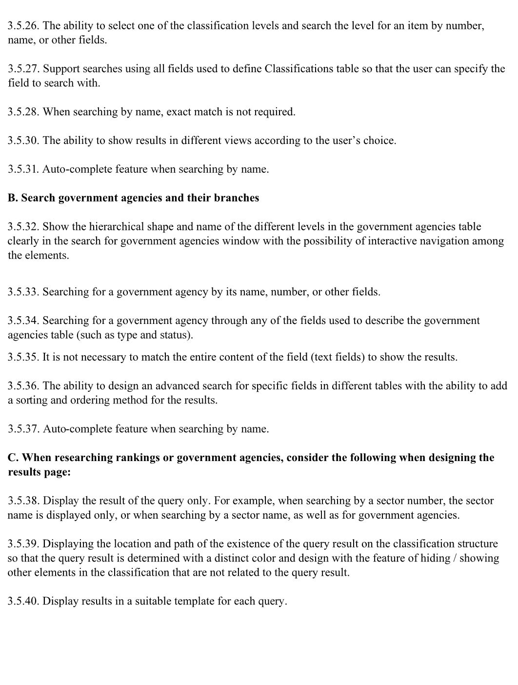

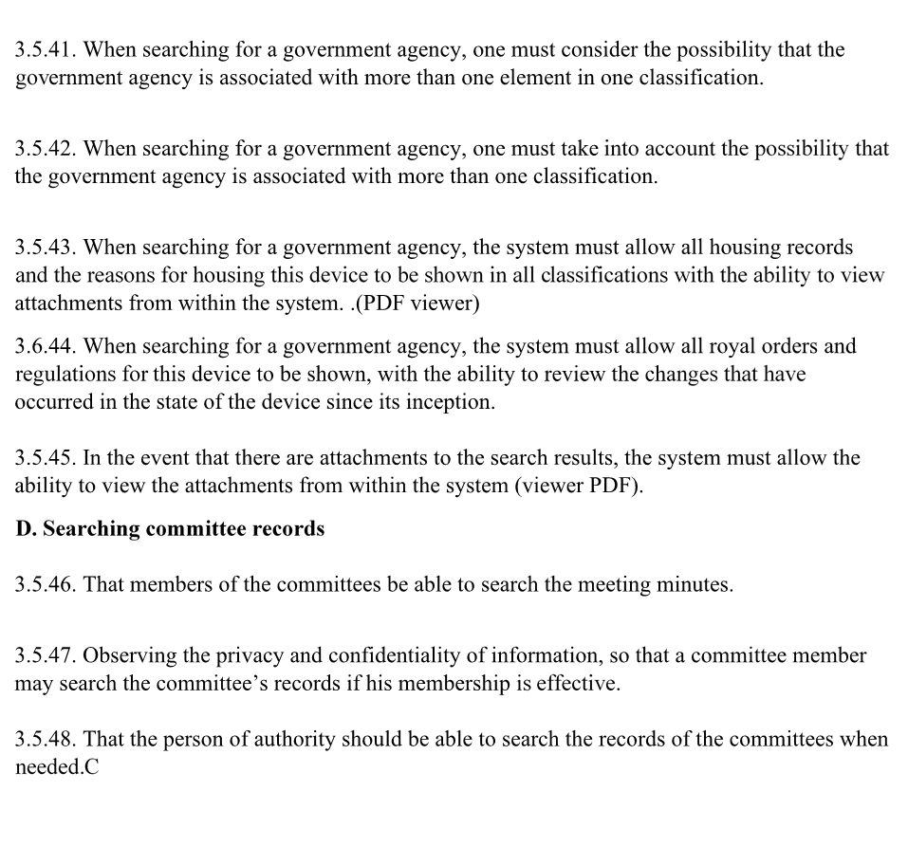

**3.6 Forms and procedures management** :

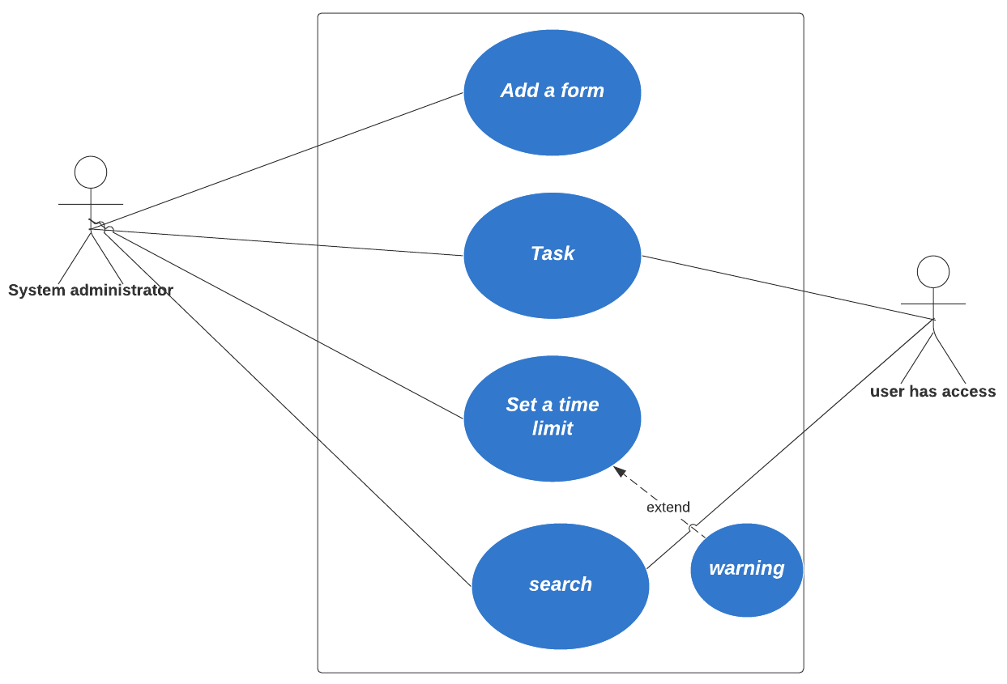

3.6.1. The system administrator must be able to define the sequence for filling out the parts of the form.

3.6.2 A committee part of the effective committees can be linked in the system so that its officials become the head of the committee to complete the task.

3.6.3. The system administrator is able to interactively define the flow of the model.  
3.6.4. Each model gives a unique, non-repeating number.  
  
3.6.5. The ability to export the form and all information related to it in pdf.  
  
3.6.6. The ability to determine the information that appears in the form when exported.

3.6.7. Add all the forms required by the National Center for Documentation and Archives and determine their path.  
  
3.6.8. There is an inbox that explains the unaccomplished tasks required of

the user.  
  
3.6.9. The presence of an outbox that shows the tasks performed by the user, their path of existence, and their status.

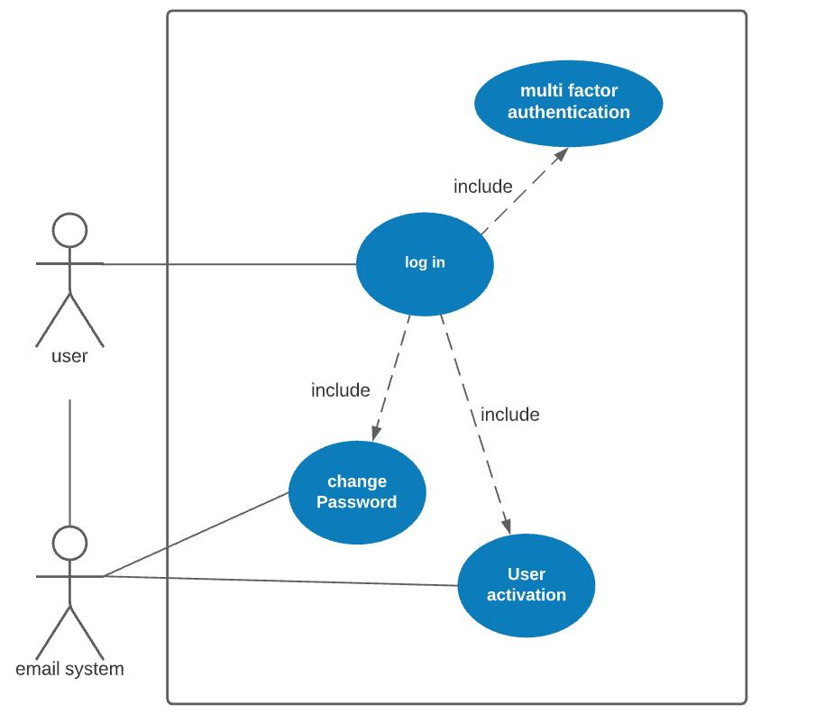**3.7 Users and privileges**

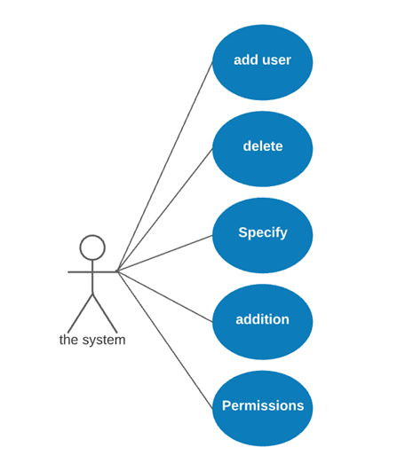



The system shall be able to

3.7.1 Providing a registration page for government agencies that includes the appropriate fields.

3.7.2 The users are activated by the system administrator and an email is sent to the user to alert the user.

3.7.3 Designing e-mail notifications in a manner that fits with the identity of the National Center for Documentation and Archives and is easy to read.

3.7.4 The possibility of inviting a specific government agency to register by sending a special link to record the data of the government agency and the system manager in the government agency.

3.7.5 Keep records showing the start and end dates of a user's membership in a group.

3.7.6 Matrix control access provides detailed access to all system operations.

3.7.7 To store users' passwords in an encrypted form.) Hashed and properly salted.

3.7.8 Managing working sessions and logging out the user in case of inactivity for a period specified by the system administrator or closing the browser.

3.7.9 The chairman of a committee is allowed to change the status of a member of the committee.

3.7.10 Providing a complete interface for the system manager to perform all tasks according to his authority.

3.7.11 The system administrator shall be able to define a password policy.

3.7.26 allow access to system administrators only from the internal network of the National Center for Documentation and Archives.

3.7.12 Implementing all system-wide modifications implemented by system administrators after being approved by another user (4 eyes principle).

**3.8 Analytics and reports**

The system shall be able to

3.8.1 A comparison between two or more government agencies based on different comparison criteria

3.8.2 Comparing branches of government agencies with each other based on different comparison criteria.

3.8.3 Comparing regions, cities or centers to each other based on different comparison criteria.

3.8.4 Comparing specific classification elements to each other based on different comparison criteria.

3.8.5 Show the comparison results in multiple views (such as text - graphs and on the geographical map).

3.8.6 Determining the comparison criteria by importing external data.

3.8.7 Create periodic and on-demand reports

3.8.8 The ability to create reports based-Event.

3.8.9 Provides a Wizard-based report builder for the system manager.

3.8.10 Wizard-based report builder shall be user-friendly wizard with clear report design process, for example in query design, selection of data source, fields and their properties.

3.8.11 Wizard-based report builder shall include builder Query with graphical illustration of the SQL instructions used.

3.8.12 Wizard-based report builder shall include several Templates and layout styles for displaying reports that fit the identity of the National Center for Document and Archives.

3.8.13 The system administrator may be able to create new templates for viewing reports or modifying existing templates based on WYSIWYG mode.

3.8.14 Export reports to various formats such as, html, excel, pdf .word

3.8.15 Support showing reports in different display ways such as tables, infographics, geographical maps, graphs, .dashboards

3.8.16 Wizard-based report builder shall support the reports and that which will be generated by the contractor, the following properties: Filters, sorting, grouping, blending.

3.8.17 Report queries shall be designed with an efficient and fast mechanism. (Query optimization)

3.8.18 the contractor shall add to the system all reports according to the requirements of the National Center for Documentation and Archives during the entire project period.

3.8.19 The contractor must attach a list of the reports that can be extracted from the system and the methods for presenting them when submitting the offer.

3.8.20 Explain a suggested working mechanism, a Wizard-based report builder, and methods of display

3.8.21 Explain how the system supports the use of external data with the system data in order to generate customized reports (for example, data of the General Authority for Statistics or other external sources of information).

3.8.22 Support for different ways to review reports (such as inside the system - Email - Print)

3.8.23 Support for different ways to review reports (such as inside the system - Email - Print)

3.8.24 That the system administrator has full authority in determining the category and users who can view a specific report

3.8.25 That the system administrator has full authority in determining the category and users who can view a specific report

3.8.26The system administrator shall be able to standardize the header and footer of all reports.

3.8.27 that the system administrator is able to change the report settings, for example orientation, direction, fonts, styles… etc.

**3.9 Technical support**

The system shall be able to

3.9.1 Providing technical support services based on the principle of support tickets according to the following tracks:

User <---> System Administrator <-----> Contractor.

3.9.2 The possibility of reopening a ticket.

3.9.3 The system administrator shall be able to determine the level of importance of the ticket.  
  
3.9.4 Automatically assign a ticket to a user according to its type.  
  
3.9.5 the technical support system shall be available even in the event that the main system is not available for some reason (by e-mail, for example.)

3.9.6 Providing a detailed analysis and reports interface (dashboard) for the status of technical support for different periods of time (for example: the number of open and closed tickets - the type of tickets - the average duration of the ticket closed in general or by type - the tickets by government agencies - by the type of ticket - by the degree of importance of the ticket, etc.) to the system administrator.  
  
3.9.7 he system administrator shall be able to specify the types of support tickets.

3.9.8 Determining a specific period of time for each support request, as a maximum for closure.

3.9.9 Issuing reports and statistics (daily - weekly - monthly - annually) for cases of support requests.

3.9.10 The contractor shall be able to generate reports on technical support according to the requirements of the National Center for Documentation and Information.  
  
3.9.9 Assignment - Withdraw - Re-assign a ticket to a user.

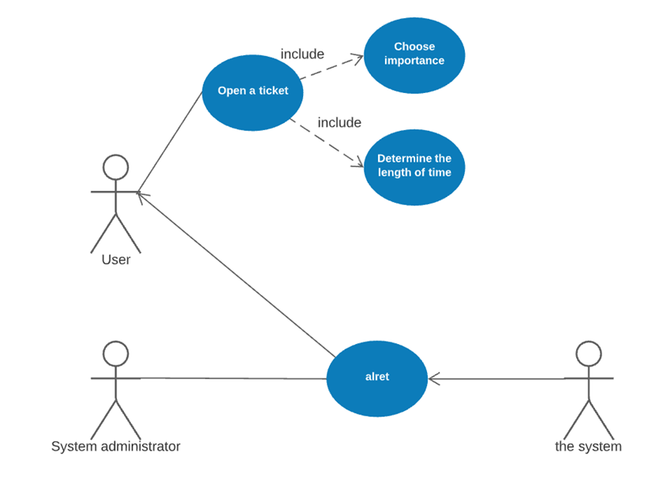

**3.10 Applicati on Programming Interface management**

The system shall be able to

3.10.1 Provides an interface for the System Manager to manage APIs.

3.10.2 The system shall provides Contact points (end point) for all the services and functions of the system.

3.10.3 the system administrator shall be able to issue a new encrypted key for use in communicating with programming interfaces.

3.10.4 each key shall associated with one user only.

3.10.5 the system shall maintains detailed information about the authorized user of the Application Programming Interface (name - government agency - email - mobile phone and else)

3.10.6 Maintain a complete, detailed record of API logs

3.10.7 Turn off a key automatically when not in use for a period specified by the system administrator.

3.10.8 The system administrator determines the maximum number of connections allowed (per day - week - month) for each key.

3.10.9 Providing statistics on the dashboard interfaces for the use of the API in general or for a specific user.

3.10.10 The ability to export user statistics in excel format.

3.10.11 storing keys in the database in an encrypted form. (Hashed and properly salted)

3.10.12 Keys are generated using the latest security standards in encryption.

3.10.13 The system administrator shall be able to set a list of allowed connections for the API (end points) for each key, and all the points are not allowed to connect with except for those in the allow list for each key.

**3.11 services search Public**

The system shall be able to  
  
3.11.1 Provide a completely independent version from the system that allows searches only. The target group for use is for all, and research is available in all classifications added to the system, which includes:

Standardized classification.

Geographical classification.

Governmental agencies and their branches

Without the need to register on the site

3.11.2 This copy is linked to the website of the National Center for Documents and Archives.

3.11.3 Searches are performed without the need to connect to the system database by extracting all database data related to searches into a single JSON or XML file that is used to show the search results, taking into account the privacy of some tables and fields when exporting the data.

3.11.4 The search and results page shall be static pages so that the search process is done and the results are shown on the user's side using an appropriate technology

3.11.5 The system administrator shall be able to extract the unified file used in searches and update it on the web server easily.

3.11.6 this version shall provides all the inquiries provided by the main version of the system.

3.11.7 this version shall provides all the results pages templates available in the main version of the system.

3.11.8 this copy shall provides all templates for the items display pages (records) available in the system.

3.11.9 The system administrator shall be able to block / unblock a specific query for this version

3.11.10 the system administrator shall be able to block / unblock certain records or fields from appearing in the results of a specific query of this copy.

**3.12 Public reports services**

The system shall be able to  
  
3.12.1 Providing a completely independent copy of the system that allows the operations to extract, display and print reports. The target group is for all

3.12.2 This copy shall be linked to the website of the National Center for Documentation and Archives.

3.12.3 This version shall allows all types of reports available in the main system, as well as reports that the system administrator can create in the main system

3.12.4 The system administrator shall be able to define a list of the reports available to show in this version.

3.12.5 The system administrator shall be able to show / hide the contents of each report.

3.12.6 the search and reports pages available to all shall use a unified data file without the need to connect to the main system database

# Other Nonfunction Requirements

**4.1 Product requirement:**

4.1 Performance /

4.1.1 -Take care to reduce the number of clicks the user needs to complete his work as much as possible (Three clicks rule if possible).

4.2 Usability /

4.2.1 -Ease of use taken into account.

4.2.2 -The system should be highly available.

4.2.3 -Conducting tests usability for different user groups.

4.3 Efficiency /

4.3.1 -The search results must appear within a period of no more than (7) seconds from the submission of the search request, regardless of the user's internet speed.

4.3.2 -Reports and statistics results must appear within a period of no more than (8) seconds, regardless of the user's internet speed.

4.3.3 -Providing technical support during a standard period, according to the nature of the problem, for the entire duration of the project.

4.3.4 -Follow the following technical support and response operations classification schedule.

|  |  |  |
| --- | --- | --- |
| Status level: | Maximum time to answer to the center: | Maximum time to solve the problem: |
| (critical)5 | 10 min | 1 hour |
| (urgent)4 | 1 hour | 8 hours |
| (high)3 | 4 hours | One day |
| (normal)2 | One day | 2 days |
| (low)1 | One day | 5 days |

.

5.4

Dependability /

4.4.1 -The system must be highly reliable in production mode.

4.4.2 -Divide the prospective users into categories and define the jobs that each category needs and how to achieve them.

4.4.3 -Clarification in the event that the contractor is a platinum or gold partner with Microsoft, with proof of that being attached.

4.4.4 -Provides an integrated dashboard for the system manager.

4.4.5 -Designing an interactive mockup containing the user journey.

4.5 Security /

4.5.1 -Full compliance with the security and protection standards and requirements approved on the hosting headquarters.

4.5.2 -Full commitment to configuring, configuring, protecting, maintaining, monitoring and managing system servers.

4.5.3 -That the contractor submits a list of three entities to carry out a security analysis of the gaps in the system (assessment Vulnerability) so that the National Center for Documentation and Archives selects one of them and the agency sends its report directly to the center for evaluation.

4.5.4 -In the event that the National Center for Documentation and Archives does not approve all the entities proposed by the contractor, the contractor proposes three other entities to carry out the security analysis.

4.5.5 -That the contractor implement all the requirements mentioned in the report of the agency implementing the security analysis.

4.5.6 -The contractor must submit a list of three entities to conduct an assessment of security risks and adhere to the standards and requirements of the National Cybersecurity Authority and OWASP standards after configuring the servers and installing the system on them so that the National Center for Documentation and Archives selects one of them and the agency sends its report directly to the center for evaluation. The list can be one to do a risk assessment as well as a security gap analysis if all agencies provide the two services.

4.5.7 -In the event that the National Center for Documentation and Archives does not approve all the entities proposed by the contractor to conduct a security risk assessment, the contractor proposes three other entities.

4.5.8 -The contractor must correct the notes in the security assessment report, according to the approval of the National Center for Documentation and Archives.

4.5.9 -Adherence to the basic cybersecurity controls issued by the National Cyber Security Authority, and any other legislation that may be issued in the future by the National Cybersecurity Authority or the owners and operators of the technical system for the unified classification of government agencies.

4.5.10 -Conducting the necessary cybersecurity assessments and resolving all observations discovered during these assessments prior to launching the system. 5.5.11 -Provided that these evaluations and observations are resolved periodically thereafter (according to the relevant legislative requirements).

4.5.12 -Activating and monitoring cybersecurity incidents on all technical components of the system (according to the relevant legislative requirements).

4.5.13 -That the contractor is committed to providing the best solutions, methods and tools used to ensure the confidentiality of information with an explanation of the mechanism for achieving this.

4.5.14 -Ensure that the technical system for the unified classification of government agencies adheres to the cybersecurity controls for sensitive systems issued by the National Cybersecurity Authority.

4.5.15 -Compatibility and connectivity with SIEM solutions at the hosting site.

4.5.16 -Provide all programs for managing and controlling the programs and the hardware used.

4.5.17 -Download, setup and configure Antivirus solution.

**4.1 Organizational requirement:**

4.6 Environmental /

4.6.1 -The system design should be based on responsive web design.

4.7 Operational /

4.7.1 -Two copies of the project were delivered for (testing and production) environments.

4.7.2 -Production copy is not interrupted when changes / updates are transferred from the development version to the production version.

4.7.3 -Clarify the mechanism for transferring changes / updates from the development version to the production version.

4.7.4 -Designing three facade molds to fit all the molds with the visual identity of the center. The National Center for Documentation and Archives will choose one of the templates as the default.

4.7.5 -Different scenarios for using the system, the users ’background and their needs, and how the system will meet these needs must be designed.

-4.7.6 -Adapt the system display with different display devices such as PC - mobile tablet.

4.7.7 -Total reliance on CSS to control the appearance of all system content.

4.7.8 -Using colors compatible with the identity of the National Center for Documentation and Archives and help facilitate reading and use of the system.

4.7.9 -Use pagination techniques to display lengthy content with a convenient progress bar.

4.7.10 -Full support for Arabic fonts in the system and database interfaces (with Arial font being used by default).

4.7.11 -Full support for the Hijri calendar according to the Umm Al-Qura calendar.

4.7.12 -Full support for the Gregorian calendar.

4.7.13 -Using the identity of the National Center for Documentation and Archives in all interfaces and designs.

4.7.14 -Obtaining the certificate SSL from an entity approved by the National Center for Documentation and Archives and affiliated to the center's account.

4.7.15 -Upload and configure the certificate on the system servers.

4.7.16 -That the contractor is committed to providing the best solutions, methods and tools used to ensure the accuracy and correctness of the Integrity information with an explanation of the mechanism for achieving this.

4.7.17 -That the contractor is committed to providing the best solutions, methods and tools used to ensure the availability of the system and uninterrupted service Availability with an explanation of the mechanism for achieving this.

4.7.18 -That the system keep records in fixed and specific formats for all the events that take place on the system (login - password error - add - modify - delete - read - search - extract a report - hold a committee session - vote ... etc.) while preserving the metadata for these events.

4.7.19 -The system administrator is allowed from within the system to view and analyze the records.

4.7.20 -Explain the mechanism for dealing with these logs, log analytics, retention, purging, exporting to log analysis tools.

4.7.21 -Activating unified government enforcement (Saudi portal).

4.7.22 -Connecting the system to the GSN network and ensuring its work, while providing the necessary devices for that when needed.

4.7.23 -Providing a complete copy of the system that can be installed on a single device that uses the Windows operating system for the purpose of collecting data from government agencies without linking with (version Standalone) servers as a demo and a mobile version.

4.7.24 -Executing the migration data transfer from the standalone system to the main system.

4.7.25 -Providing an Excel file that enables government agencies to enter the data of their branches in fields identical to the fields used in the system.

4.7.26 -The ability to import the entity’s information into the system and all of its branches ’information from the excel file sent to them to fill in the data.

4.7.27 -The installation and configuration process should be done using documented and annotated scripts in English, not manually.

4.7.28 -Carrying out testing operations that include, for example, but not limited to unit, functional, integration tests, and documenting them, and delivering tests and documentation to the center.

4.7.29 -Submit a functional specification document to the center for review and approval.

4.7.30 -Design diagrams for all system pages must be submitted to the center, including all possible scenarios for using the system, for approval and review before implementation.

4.7.31 -Submit a detailed document for the shapes of the interfaces, taking into account the needs and journey of the user (the wireframe).

4.7.32 -Providing a user guide for the system with all its contents and functions.

4.7.33 -Submit a detailed document with pictures and the steps for the installation and configuration process for the system on the hardware as well as for the programs.

4.7.34 -Submitting a detailed document explaining all the details of the system, the structure of its various parts, the mechanism of their operation and their interconnectedness.

4.7.35 -Submitting a detailed document for the system analysis and design stage, including, for example, ERD and DFD models.

4.7.36 -Submitting a document with a detailed explanation of the database that includes tables, fields, data types, main and foreign keys, and everything related to the database.

4.7.37 -Providing a detailed document for all the programs and intangible components (software costs) required by the system, including the programs and the available maintenance and support period.

4.7.38 -Documenting and writing a clear explanation of all the codes in the English language.

4.7.39 -Follow the principles of Object Oriented Programming.

4.7.40 -All code should be modular.

4.7.41 -Submit a detailed document for the entire project codes.

4.7.42 -Deliver a detailed document with a detailed and accurate explanation of all the points end components used in the programming interfaces, the method of connection to them, the variables, and the form and format of the outputs.

4.7.43 -Submit a detailed document explaining examples of using APIs using more than one language including JAVA and JavaScript.

4.7.44 -List all documents (technical and project management related), their details and the stages of their delivery to the National Center for Documentation and Archives.

4.7.45 -Delivery of the source code in full, provided that it is the property of the National Center for Documentation and Archives.

4.7.46 -When using external software libraries, the numbers of copies used, all their links, and other libraries that depend on them (list dependency) must be clarified with full details.

4.7.47 -When using external software libraries, these libraries must be in the most recent versions and supported for a period of not less than 3 years.

4.7.48 -When using external software libraries, legal licenses must be obtained.

4.7.49 -Deliver a copy of the source code after each modification or change throughout the maintenance and support period.

4.7.50 -The National Center for Documentation and Archives owns the entire source code of the project even after the maintenance period ends.

4.7.51 -Using version control software.

4.7.52 -Emphasize the importance of writing effective software codes that do not consume excessive material resources.

4.7.53 -Stress testing to ensure the ability of the system and the proposed hardware settings to endure, provided that the relationship between the increase in the number of users and the response speed is not exponential.

4.7.54 -When providing software components, this must be done through the developing company or its official agent.

4.7.55 -Clarify the mechanism for using a software-based load balancer on the web server if needed.

4.7.56 -The mechanism of recovery, restoring system data, and system work in emergency cases are clarified.

4.7.57 -Providing, installing, configuring, and managing Windows 2019 server operating system on system servers.

4.7.58 -Provide, install, configure and manage SQL Server 2019 on system servers.

4.7.59 -Providing licenses for all used programs and APIs.

4.7.60 -Holding a training workshop on the system for system administrators at the National Center for Documentation and Archives.

4.7.61 -Holding 2 workshops for members of the committees at the National Center for Documentation and Archives to use the committees system.

4.7.62 -Holding 2 workshops for the center's employees for the general use of the system.

4.7.63 -Conducting 11 training workshops for system administrators in government agencies.

4.7.64 -Displaying questions and answers to facilitate use from inside and outside the center.

4.7.65 -Manuals and films explaining the technical use of classification.

# Other requirements

* The proposed solution must use a three-tier servers' architecture: (Web server, Application server, Database server).
* Clarify the proposed technical specifications for all devices.
* When providing hardware, this must be done through an authorized agent capable of providing technical support and spare parts for a period of not less than 5 years.
* That the contractor clarifies the upper limit for the users that the system can serve at the same time without affecting the performance of the system.
* Physical solutions must be able to respond to at least (1000) requests per second without affecting response speed.
* Physical solutions must be able to handle a minimum of (100,000) users per day.
* Clarify the technical specifications of the SAN storage device.
* Clarify the maximum number of requests that the system can handle according to the proposed structure without the need to add new servers.
* Providing the necessary hardware to connect the system servers to the GSN.
* Add a list of necessary physical solutions.
* That the contractor adheres to the standard specifications of the physical components approved at the hosting headquarters and according to the requirements of the National Center for Documentation and Archives.
* Conducting a field visit to the hosting headquarters to learn about the requirements and needs, comply with them and fully comply with them.

# System Models:

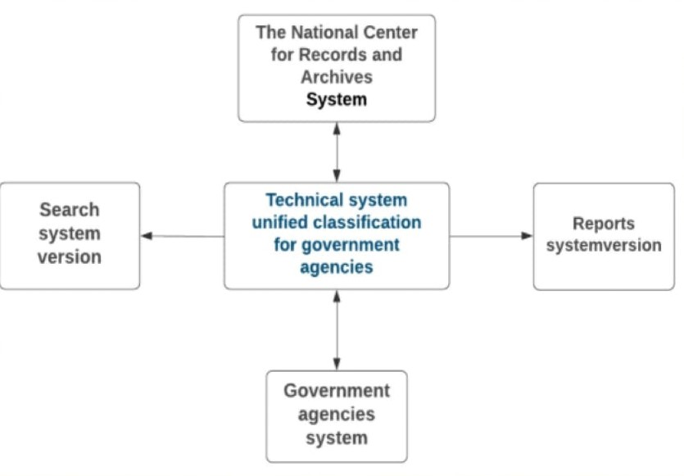

Figure -System interactions Context Diagram

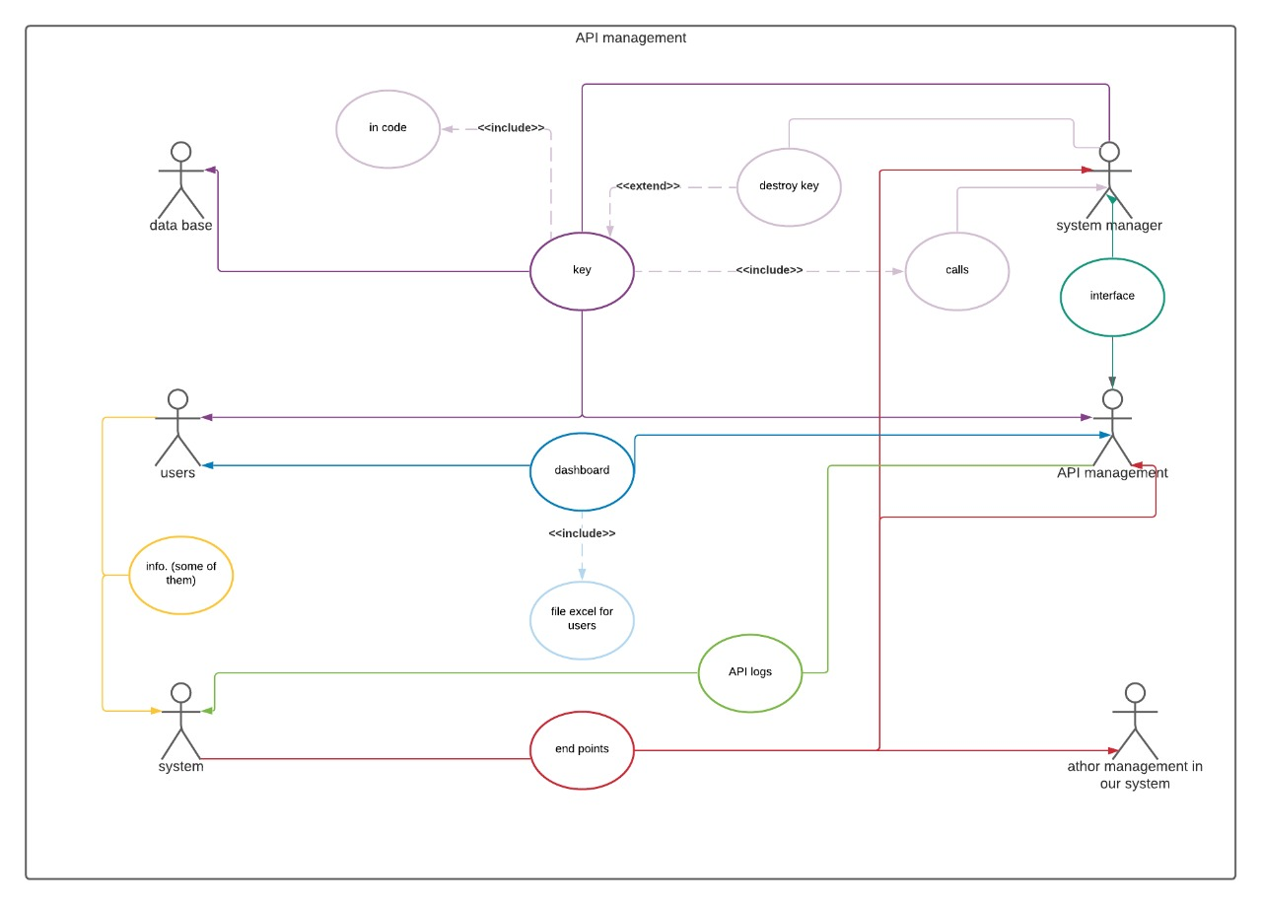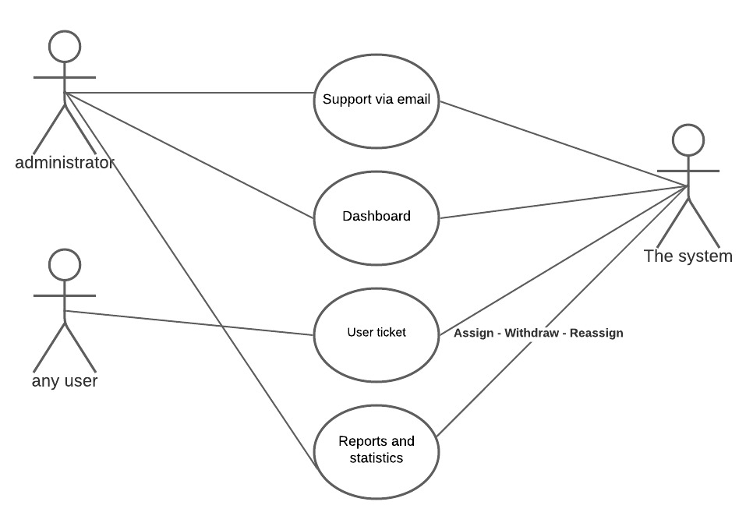

Figure -Technical support use cases

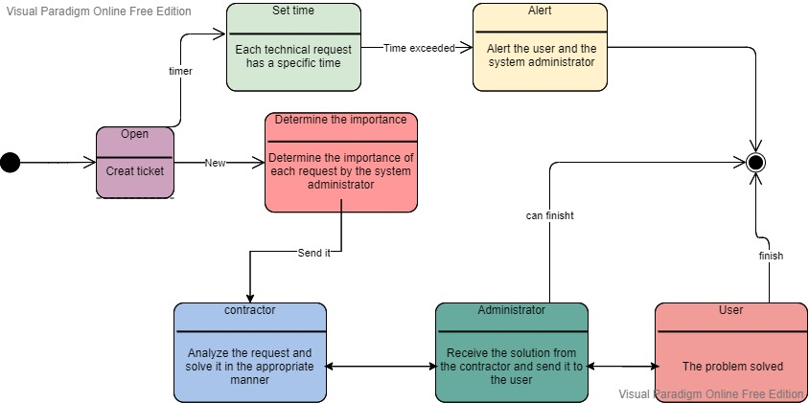

Figure -Technical support State diagram

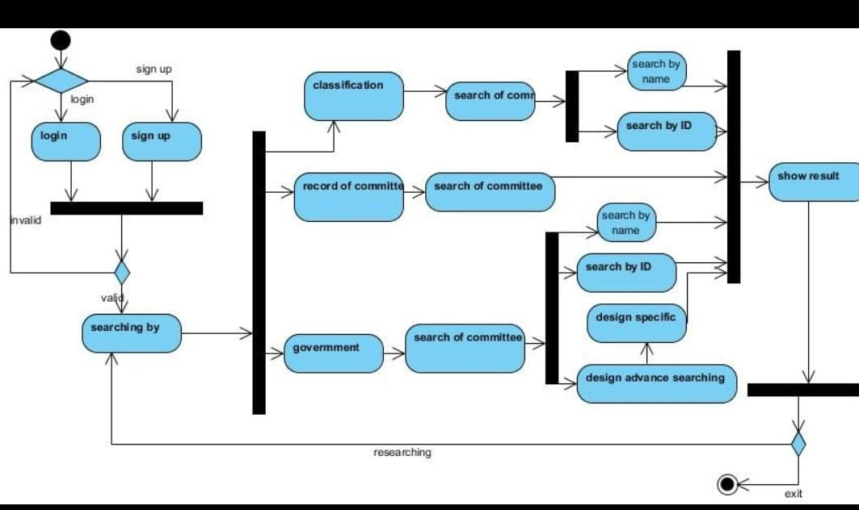

Figure -Search services Activity diagram

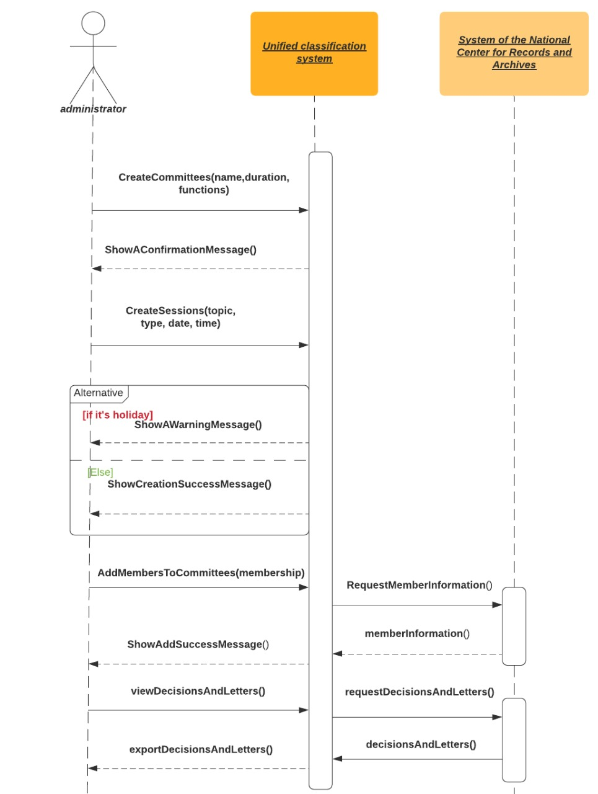

Figure 7-Managing Committee Members Sequence Diagram

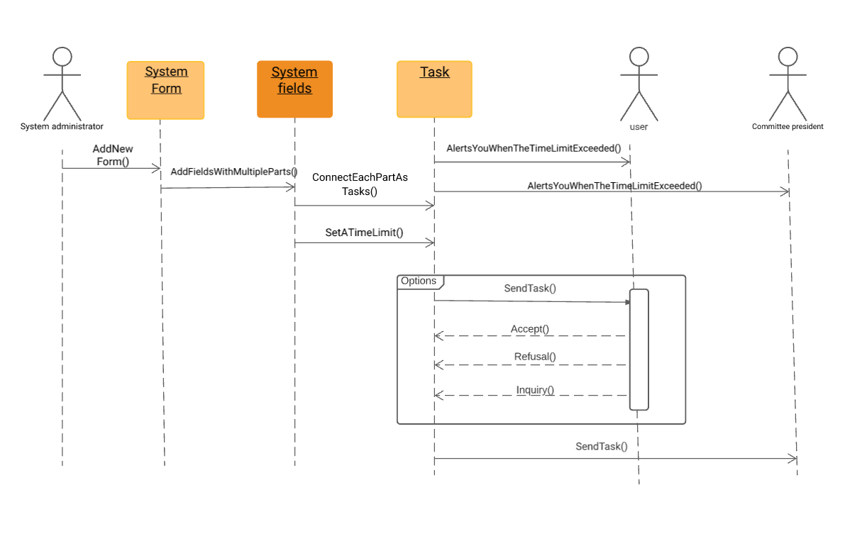

Figure 8-Form management Sequence diagram

# Sprint:

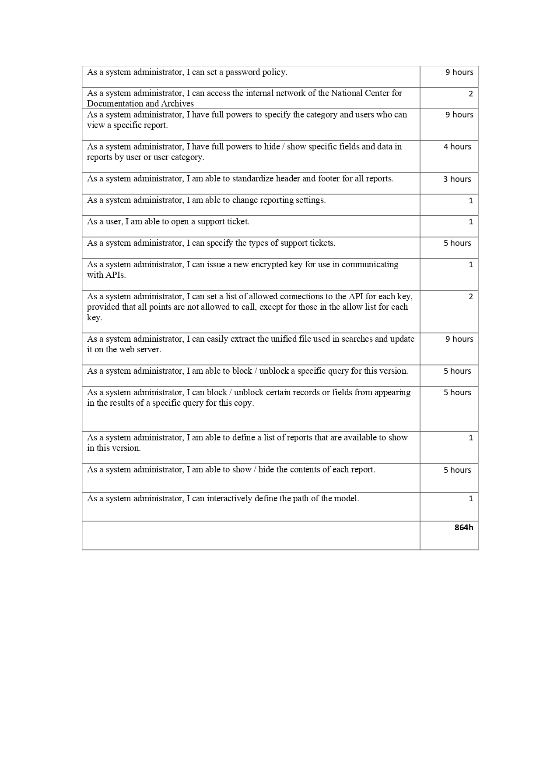

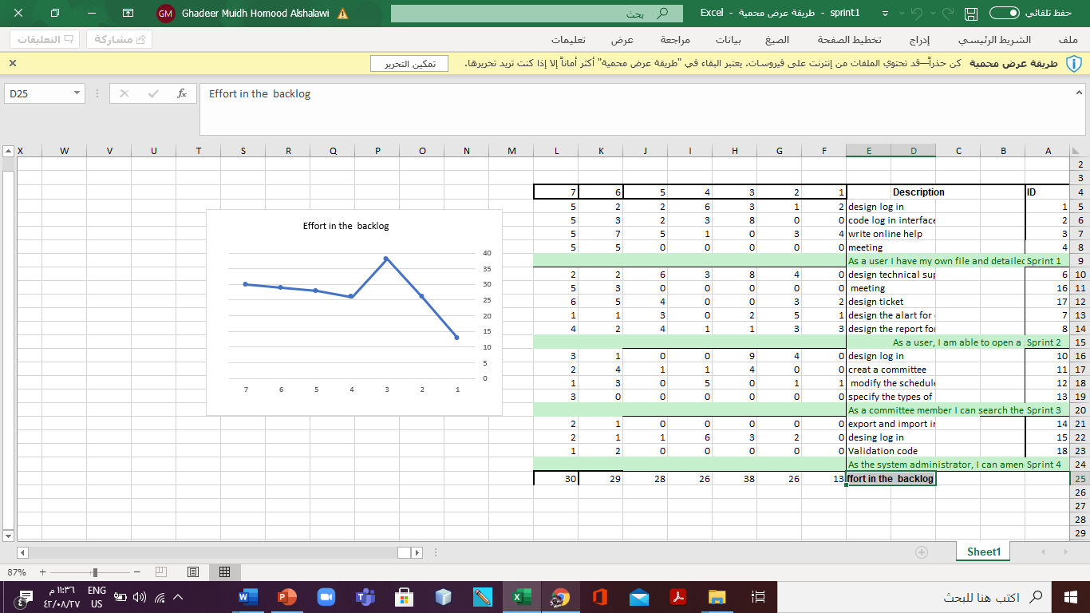

# System interfaces:

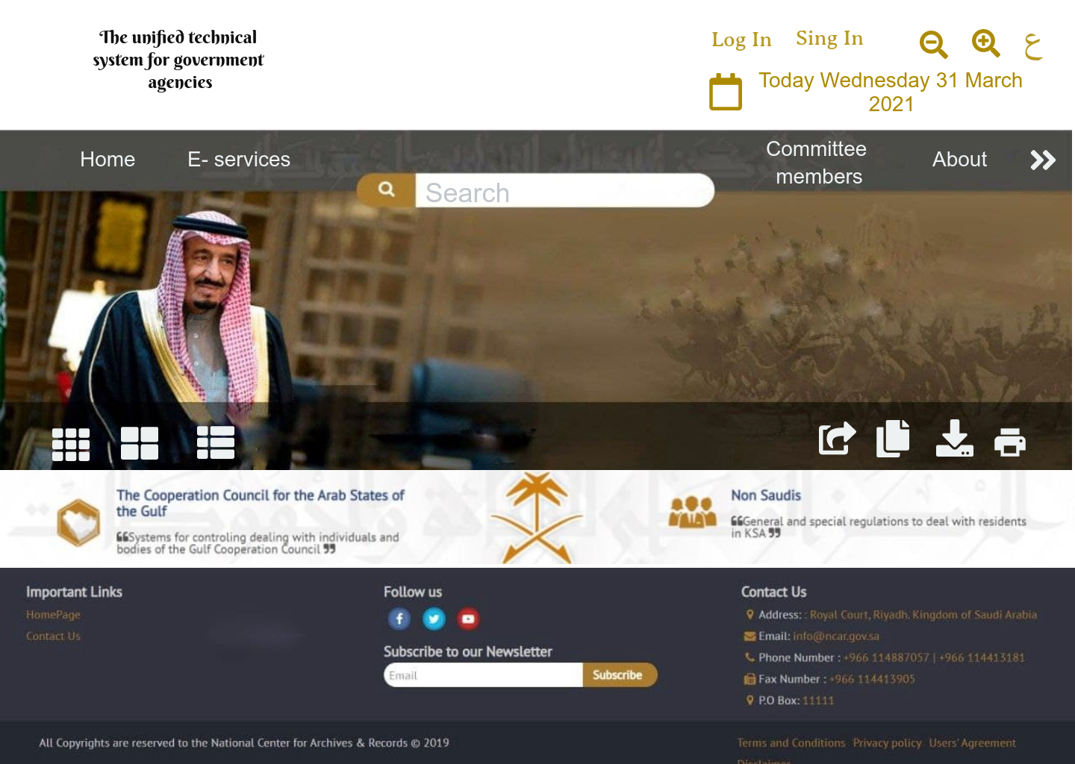

Figure 8-Home page

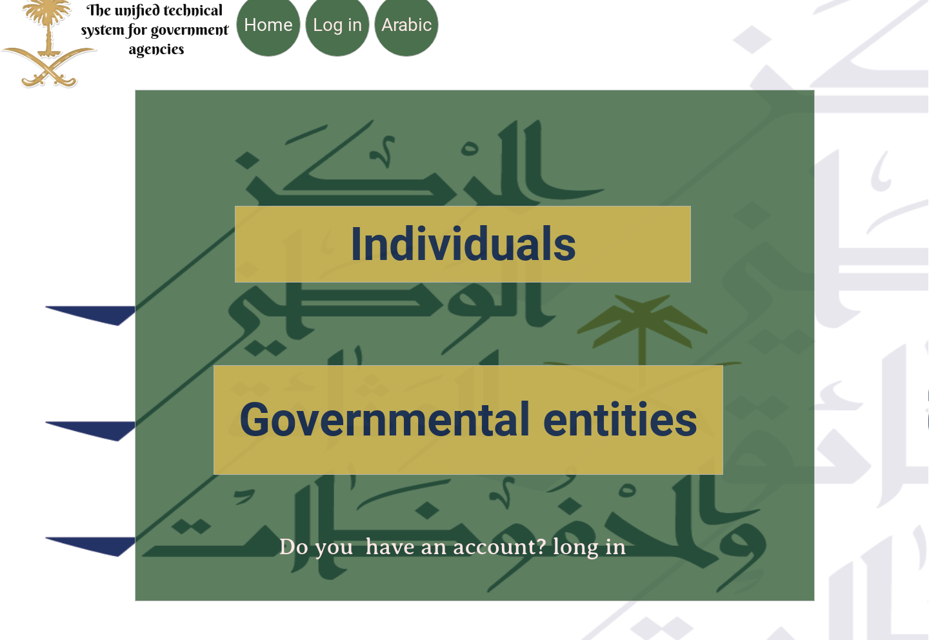

Figure 9-Sign In Page

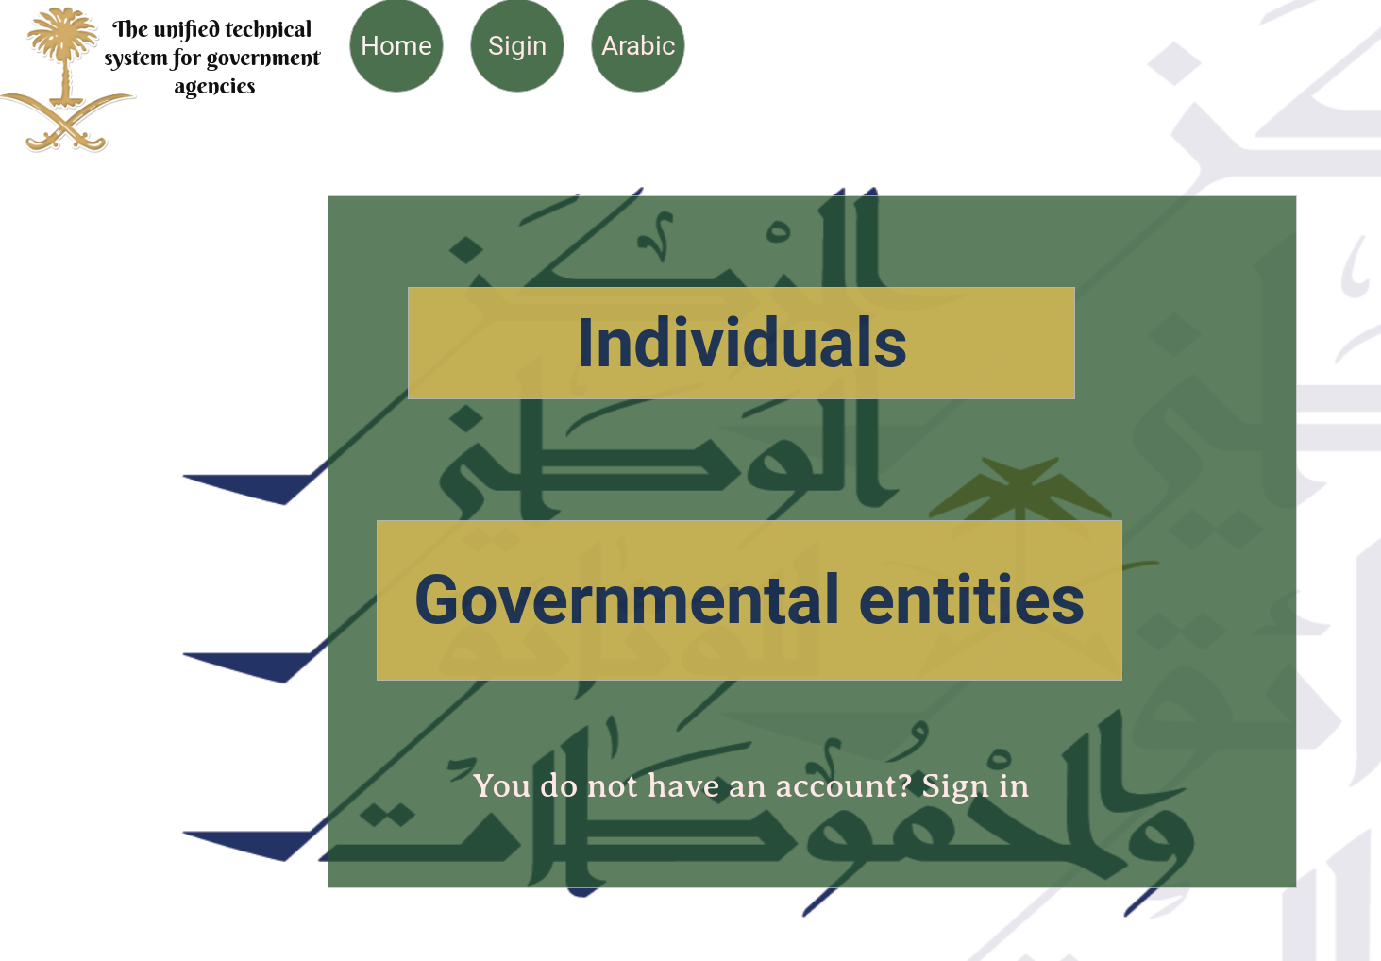

Figure 10-Login page

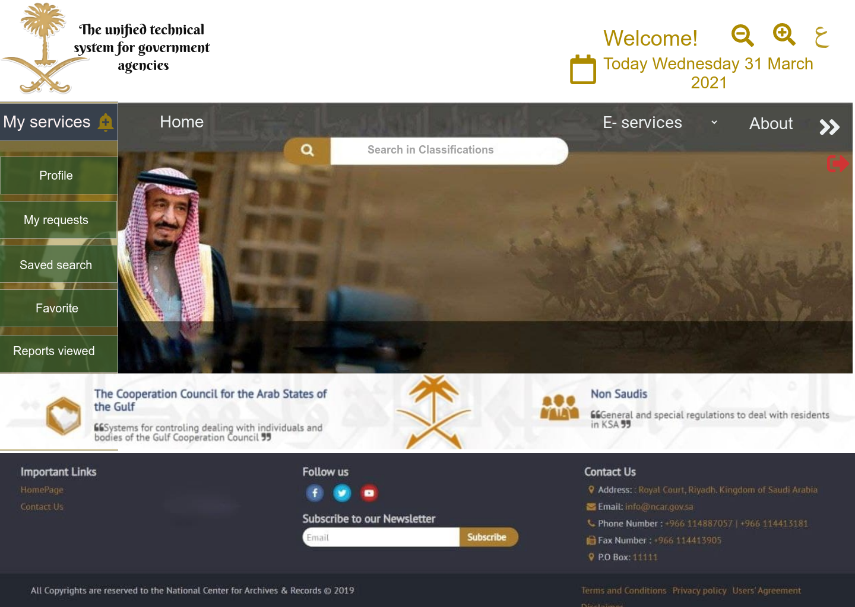

Figure 11-Individuals entry page

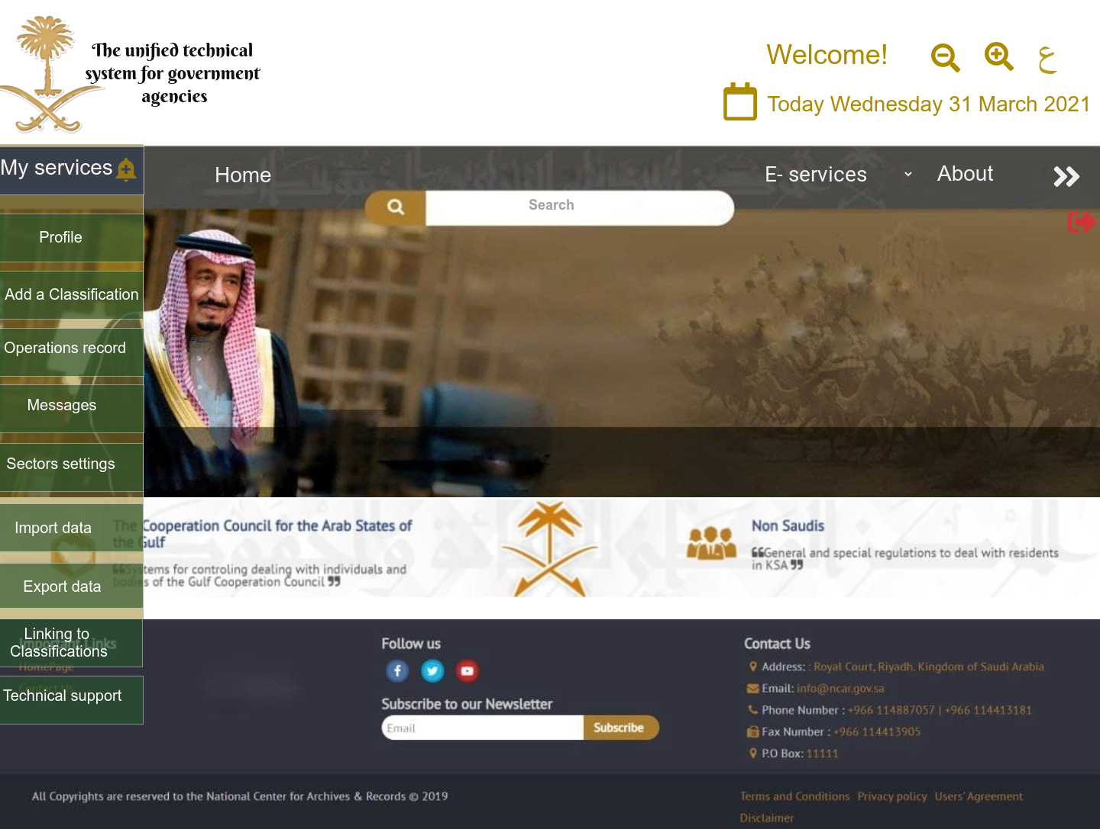

Figure 12-Government Entities Entry Page

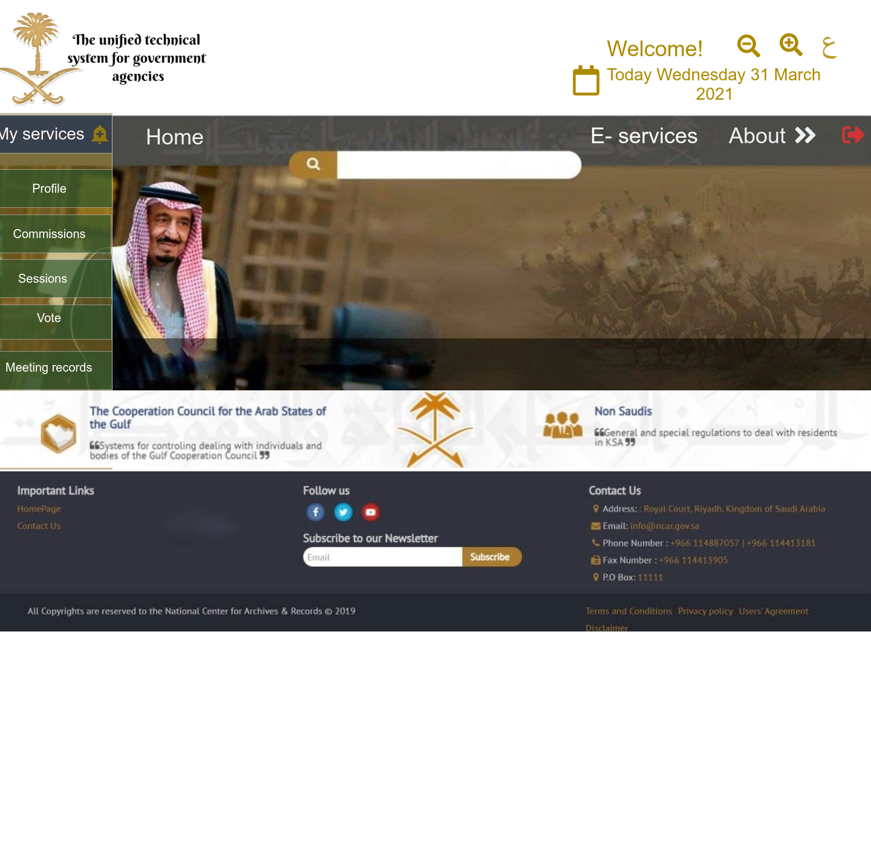

Figure -Committee members Entry page

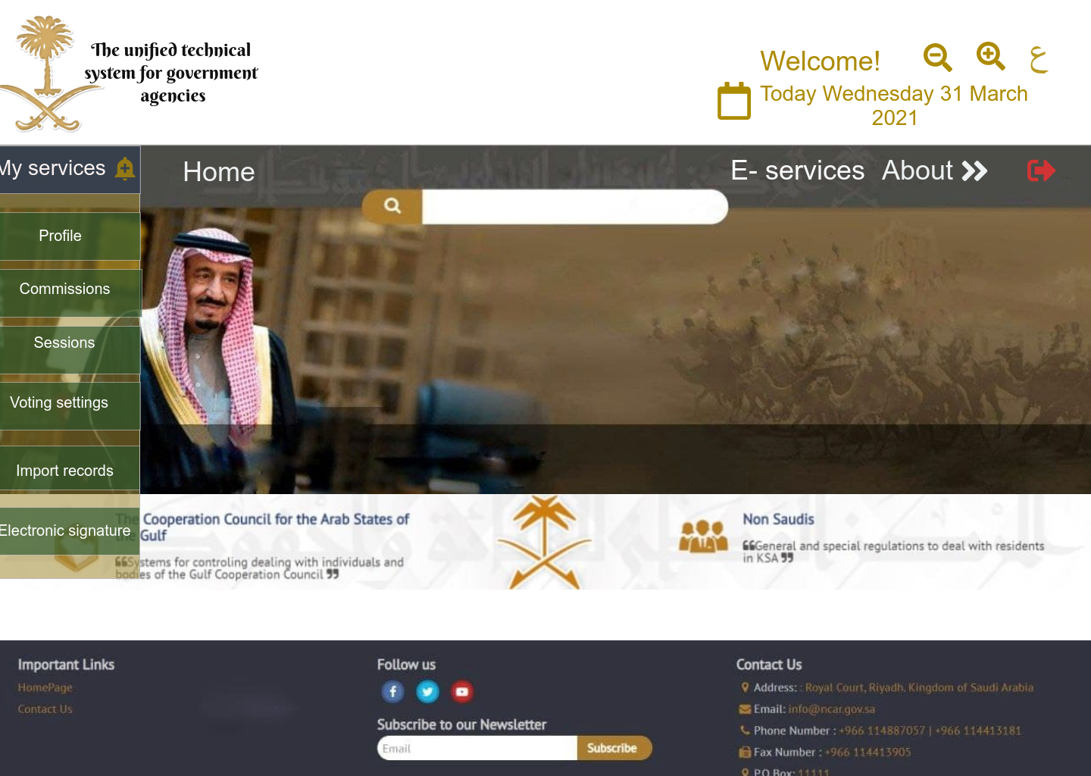

Figure -Committee Admin Entry page

# Link to the prototype:

https://mockittapp.wondershare.com/app/1e976895f686f378df4d2f9fa69b7a3988277fe8?simulator_type=device&sticky

# architectural design and pattern:

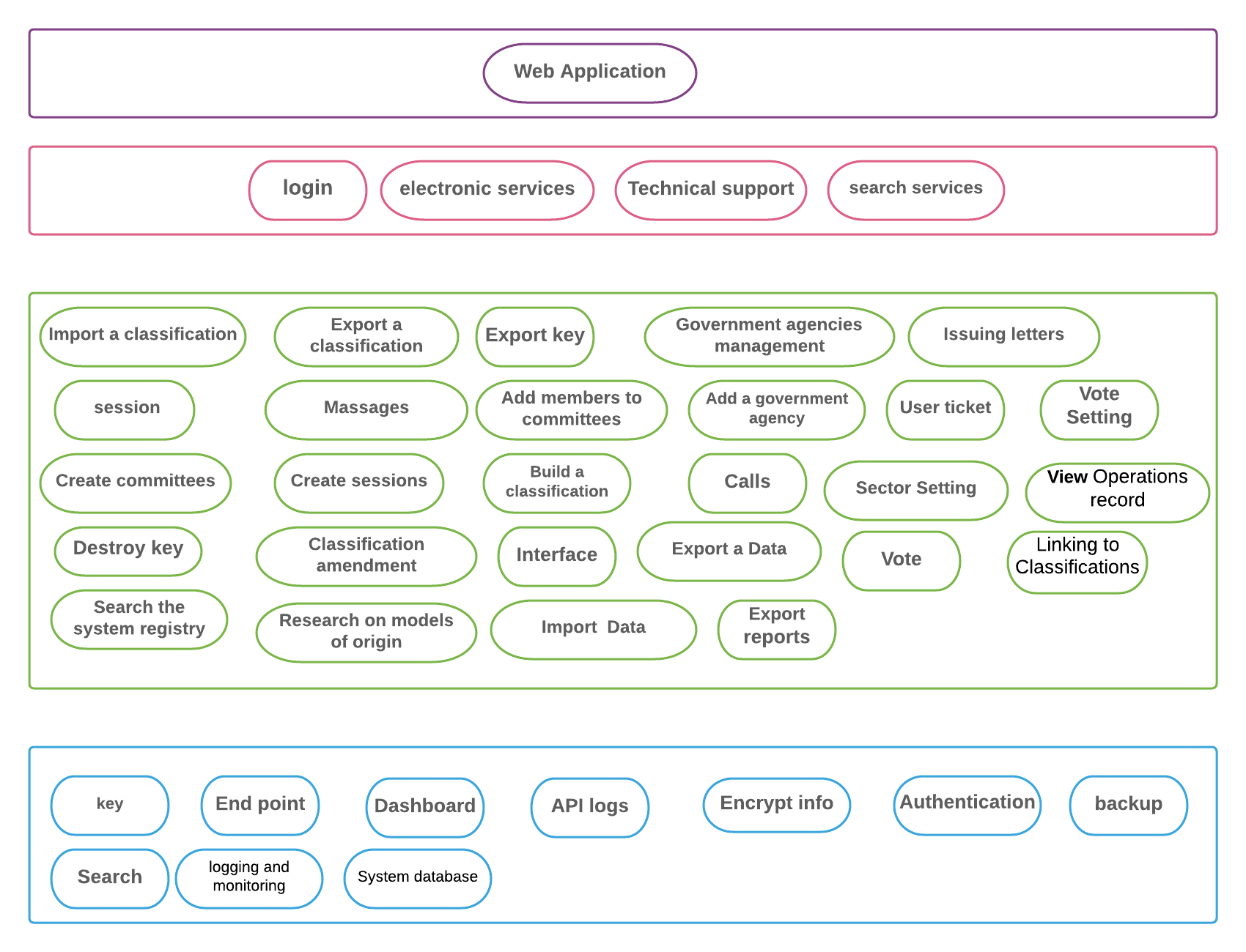

**Why we choose this** **Architectural patterns**

* We chose the Layered architecture ,Because our system is multiple and contains several subsystems , Each system is connected to the main system. We chose the layered Architectural because it is very convenient to deal with the system , The first layer has to communicate with the external user represented by the user interfaces The middle layer of subsystems is the intermediate structure between the user interfaces and the internal system as a whole.

and it Used when building new facilities on top of existing systems

And also the features of the Layered architecture :

* Used when building new facilities on top of existing systems.
* Layered architecture increases flexibility, maintainability, and scalability.
* Multiple applications can reuse the components.
* Layered architecture enables teams to work on different parts of the application parallely with minimal dependencies on other teams.
* Layered architecture enables develop loosely coupled systems.
* Different components of the application can be independently deployed, maintained, and updated, on different time schedules.
* Layered architecture also makes it possible to configure different levels of security to different components deployed on different boxes.
* Layered architecture also helps you to test the components independently of each other.

# The implementation:

# Sign up Page:

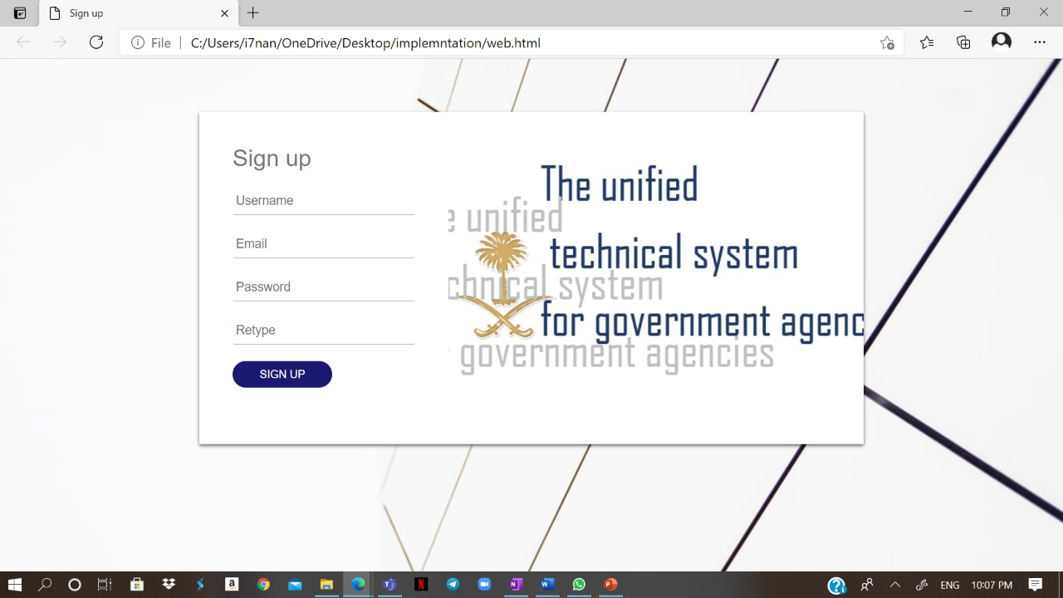

|  |  |  |  |  |  |
| --- | --- | --- | --- | --- | --- |
| Classification of expenditures according to sectors and groups according to government functions and it symbols | | | | |  |
| Categories | groups | Sectors | symbols | |  |
|  |  | Public services |  |  | 701 |
|  | Executive and legislative  organs, financial affairs, public  finance affairs, and foreign  affairs |  |  | 7011 |  |
| Executive and legislative bodies (general services) |  |  | 70111 |  |  |
| Financial Affairs for Public Financial Affairs  (General Services) |  |  | 70112 |  |  |
| Foreign Affairs (General Services) |  |  | 70113 |  |  |
|  | Foreign economic aid |  |  | 7012 |  |
|  |  |  | 70121 |  |  |
|  |  |  | 70122 |  |  |
|  | public service |  |  | 7013 |  |
| General Personnel Affairs Services (General Services) |  |  | 70131 |  |  |
| Comprehensive statistical planning services  (general services) |  |  | 70132 |  |  |

# Appendix: